[Title]

RESULTS

**Searches and screening**

* A total of 3,790 records were identified through the electronic database searches, with a further 5,191 records identified through supplementary hand searches. Following the removal of duplicates, screening of abstracts and full-text articles, and de-prioritisation of SLRs reporting on overlapping interventions, a total of 106 publications were ultimately included in the umbrella review. This included 78 SLRs and 28 economic evaluations. The results of each stage of the screening process are presented in the Preferred Reporting Items for Systematic Reviews and Meta-Analyses (PRISMA) diagram in Figure 1.

**Summary of reported outcomes and interventions**

* Out of the 106 publications included, 36 SLRs reported pooled outcome data measured via the priority effect measures (either NNT, RR or OR). Twenty-eight economic evaluations reported QALYs. Among these, 40 publications assessed behavioural interventions, 16 assessed socio-economic interventions and nine were included in the NICE NG115 guideline and assessed pharmacological or surgical interventions (Table 1). None of the identified SLRs or EEs assessed environmental interventions.
* The most commonly reported behavioural interventions were pulmonary rehabilitation (PR) or integrated disease management, followed by Traditional Chinese Medicine (TCM), including acupuncture, as well as herbal preparations. Other commonly reported behavioural interventions were home management or discharge management; self-management or patient education and smoking cessation treatments.
* Socio-economic interventions were predominantly telehealth or telemonitoring, as well as interventions focused on early detection of COPD, self-management, home management and pulmonary rehabilitation.
* Pharmacologic and surgical interventions included in SLRs informing the NICE NG115 guideline were lung surgery, inhaled therapies, oxygen therapy, corticosteroids, antibiotics and smoking cessation aids to manage COPD.
* The most frequently reported outcome was QALYs (n=157 data points). For OR, RR or NNT effect measures, most frequently-reported outcomes were reduction in COPD symptoms (n=83), hospitalisations (n=72), mortality (n=57), adverse events (n=49) and reduction in exacerbations (n=41) (Figure 2). Overall, most SLRs only reported on a single outcome, with the exception of studies assessing pharmacological or surgical interventions where the majority of studies reported on multiple different patient outcomes (Figure 4). Outcomes were assessed for a wide variety of interventions, as shown in Figure 2.
* A further 42 SLRs reported other, more heterogenous effect measures, such as exercise capacity measured via the 6-minute walk distance (6MWD) test or lung function using forced expiratory volume (FEV). Thirty-nine publications reported on behavioural interventions, two reported on socio-economic interventions and one reported on environmental interventions (Table 2).
* Among SLRs that reported other measures, exercise capacity (n=43 data points), pulmonary function (n=32), health-related quality of life (HRQoL) (n=19) and respiratory symptoms such as dyspnoea (n=13) were the most commonly reported outcomes.
* Behavioural interventions made up the majority of the evidence base, predominantly interventions promoting increased physical activity (n=6 studies), such as yoga,1 meditative movement,2 Tai Chi3 and other Chinese exercises,4 as well as water-based exercise training5 and promotion of physical activity using a step counter.6
* Interventions promoting smoking cessation (n=3 SLRs), included an evaluation of behaviour change techniques,7 legislative smoking bans,8 and switching from cigarettes to e-cigarettes.9
* There was also a moderate number of SLRs reporting on nutritional or testosterone supplementation10 (n=6 studies), with the former including beetroot juice11 and other nitrate supplementation,12 as well as increased intake of omega-3/6 fatty acids,13 and nutritional supplements more broadly.14, 15
* Other more holistic interventions such as acupuncture or TCM were reported by 11 studies.16-26
* Socio-economic interventions included the involvement of caregivers in self-management interventions, which was found to have no impact on the assessed outcome of health-related quality of life,27 as well as using community health workers to help manage asthma or COPD.28 The use of community health workers was associated with improvements in asthma-related outcomes, while no evidence related to COPD-specific outcomes was identified.28
* One study assessed environmental interventions, a Cochrane SLR assessing the impact of individual level interventions such as wearing masks, altering cycling routes and using air pollution alerts to reduce personal exposure to outdoor air pollution. 29 Outcomes assessed included physiological markers of air pollution, health care usage and respiratory symptoms, however a low level of overall evidence and high in-between study heterogeneity meant that no firm conclusions could be drawn on the effectiveness of individual level interventions.29

**NNT, HR or OR**

*Hospitalisations*

* A total of 17 SLRs reported on the effect of interventions on hospitalisation rates (Figure 4). Across reported categories, the interventions were largely favoured compared with usual care, however, this was not always statistically significant.
* For integrated care-based interventions, including pulmonary rehabilitation, action plans and self-management interventions, pooled ORs for hospitalisation reported by seven SLRs ranged from 0.13 to 0.75 (always in favour of the intervention vs control).30-36
* Findings for discharge- or home-based care-related and telehealth-related interventions were more mixed. For example, home care via outreach nursing resulted in a pooled OR of 1.01 in one SLR,37 while reported RRs were 0.86, 0.67 and 0.5 for ‘hospital at home’, structured discharge interventions and pharmacist care, respectively.38-40 Similarly, two out of four SLRs reporting telehealth-related interventions found no demonstrated benefit of the intervention (RR of 1.33 for exercise therapy via advanced telehealth technology,41 OR of 1.21 for remote monitoring42 – each based on pooled data from two primary studies). Meanwhile, another SLR that assessed telemonitoring interventions reported an RR of 0.88 (based on data pooled from 14 primary studies).43
* The NNT to prevent hospitalisation was reported for five interventions (Table 3) and ranged from 4.5 to 29 for structured discharge interventions with 360 days or 180 days of follow-up, respectively.44

*Emergency department visits*

* Five SLRs reported on the effect of interventions on the number of emergency department visits (Figure 5),30, 34, 36, 43, 45 including integrated care and telehealth interventions. The interventions were favoured for all five studies compared with the comparators, reported to be statistically significant for four interventions: action plans (OR 0.55),30 integrated disease management (OR 0.69),34 self-management (OR 0.53),36 and telemonitoring (RR 0.63).43 NNT was reported for one intervention, implementing action plans, with 12 patients needing to be treated to prevent one ED visit.30

*Mortality*

* All-cause and respiratory-related mortality was reported by 26 SLRs (Figure 6). Across the different interventions, trends were mixed and most results were not statistically significant, with the exception of combined resistance and endurance training (OR 0.39)46 and maintenance pulmonary rehabilitation (supervised exercise at lower frequency than initial PR programme; OR 0.21)47 showing statistically significant improved outcomes compared with usual care. No NNT were reported across studies.

**QALYs**

* A total of 31 studies reported on QALYs of interventions compared with a usual care treatment, as summarised in Table 4. The majority of interventions were associated with an incremental increase in QALY compared with their relevant comparators.

**Other Effect Measures**

* Across the SLRs reporting behavioural interventions that were not assessed via the priority effect measures, outcomes, including exercise capacity, lung function, respiratory symptoms and HRQoL were generally improved across all interventions.
* All three SLRs that assessed interventions targeting smoking cessation reported positive conclusions in terms of improvements in patient outcomes such as quitting smoking, lung function and hospitalisation rates.7-9
* Similarly, lung function and respiratory symptoms such as dyspnoea were largely improved following interventions such as music therapy,48 singing49, 50 and breathing exercises,51 including pursed lip breathing during exercise52 or combined with diaphragmatic breathing.53
* Inhaler adherence, COPD exacerbation rates and disease control were improved following inhaler technique education and using an inhaler adherence toolkit for health care professionals managing COPD patients.54, 55
* The majority of SLRs reporting on nutrition- or supplement-related interventions did not capture sufficient evidence to draw firm conclusions on whether they improved patients’ exercise capacity, lung function or HRQoL.10-15 A similar lack of evidence to base conclusions upon was highlighted for SLRs investigating acupuncture and TCM.16-26
* The involvement of caregivers in self-management interventions was found to have no impact on health-related quality of life in one SLR.27 In another SLR, use of community health workers was associated with improvements in asthma-related outcomes, but insufficient evidence related to COPD-specific outcomes was identified.28

**Quality assessment**

* Results of the quality assessments conducted for SLRs reporting on NNT, RR or OR effect measures, as well as for EEs are reported in Figure 7.
* Following assessment with the AMSTAR-2 checklist, approximately half (16/31) of studies were at low risk of bias for the majority of domains, including use of the PICO framework as basis for the eligibility criteria, study selection methods and adequately detailed reporting of included studies and their risk of bias. Conversely, a total of 3 studies were at high risk of bias for the majority of domains, with descriptions of excluded studies, funding or sponsorship sources of included studies, and discussions of publication bias being the most poorly reported domains assessed by AMSTAR-2.56-58
* Similarly, following quality assessment with the modified checklist by Drummond *et al*., 10/25 economic evaluations were at low risk of bias for >20/27 of the assessed domains, while 4/25 economic evaluations were judged to be at a high risk of bias for the majority of the domains,59-62 highlighting a poor quality of methodological reporting.

DISCUSSION

* A high volume of evidence was identified regarding interventions aimed at managing COPD. However, the majority of the evidence was low-to-moderate quality, with few SLRs identifying high-quality RCTs. More research is needed to assess whether behavioural, socio-economic or environmental interventions have an impact on the management of COPD
* Environmental interventions in particularly have not been assessed in detail. Primary studies not captured in an SLR were not captured in this umbrella review, however there are some existing primary studies assessing environmental interventions. These include Hahn et al. 2014 and Dusemund et al. 2015, both of which assessed the impact of smoke-free public policy
* The evidence base was highly heterogenous, making it challenging to compare interventions and outcome measures between different studies, both within individual SLRs, as well as between SLRs. Furthermore, the majority of outcomes were only supported by a small number of studies

TABLES AND FIGURES

Figure 1. PRISMA diagram

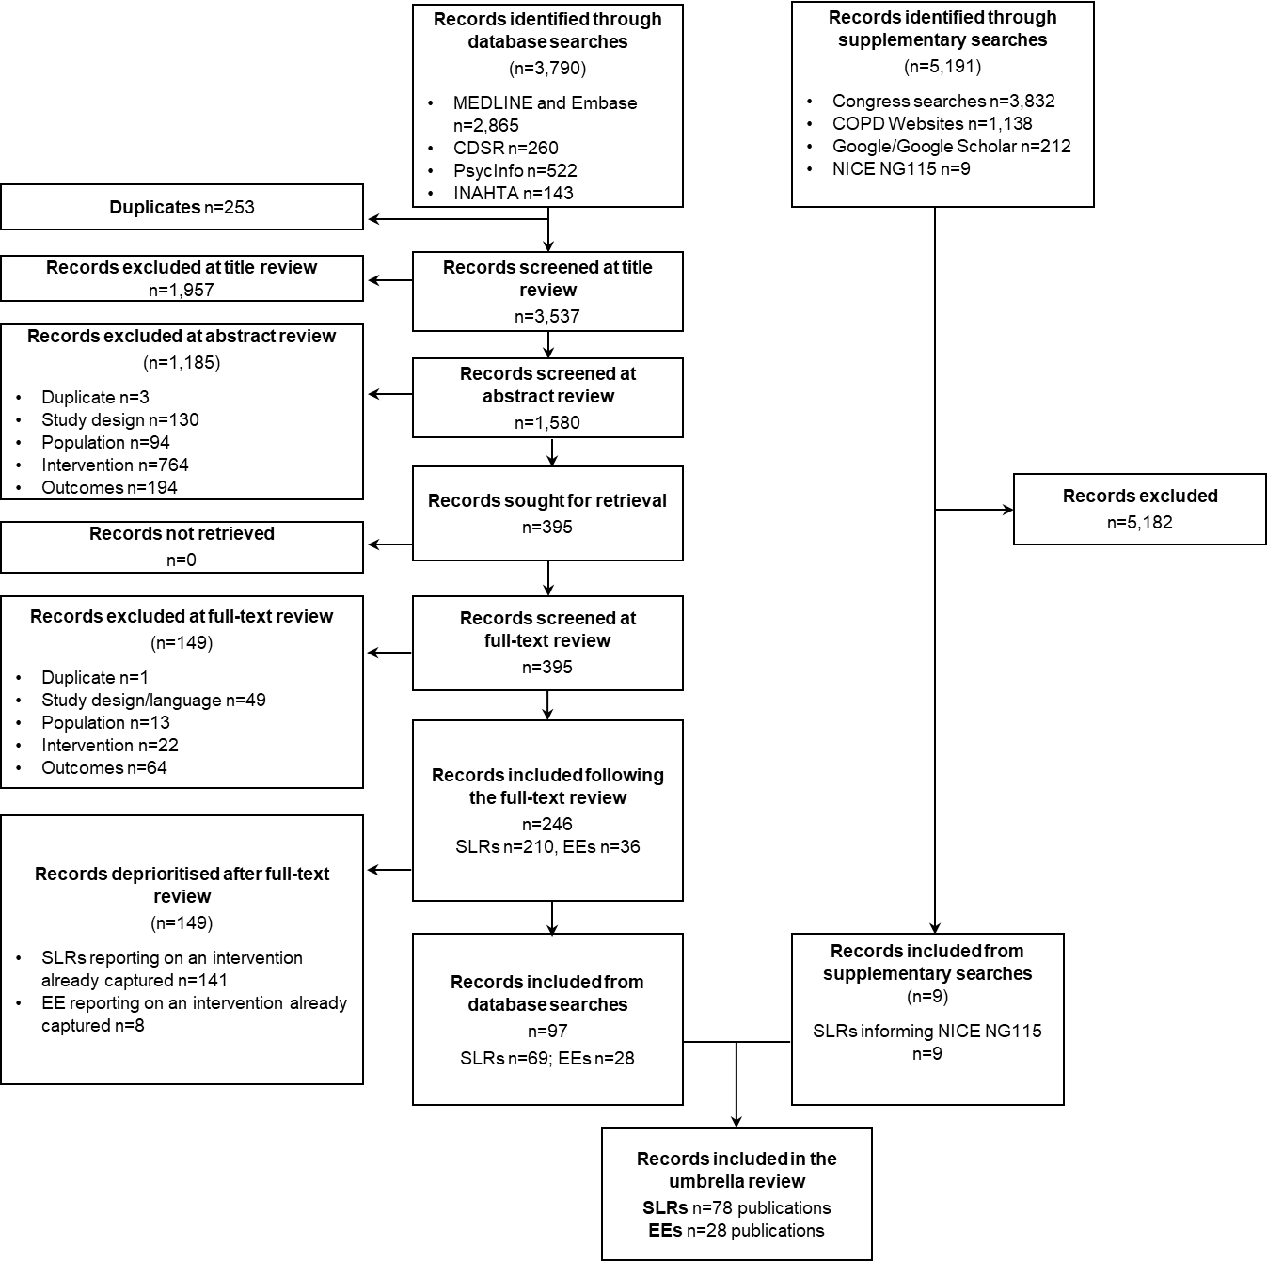

**Abbreviations:** COPD, chronic obstructive pulmonary disorder; CDSR, Cochrane Database of Systematic Reviews; EEs, economic evaluations; INAHTA, International Network of Agencies for Health Technology Assessment; NICE, National Institute for Health and Care Excellence; SLR, systematic literature review.

Figure 2. Summary of (A) interventions and (B) outcomes in studies reporting QALYs, NNT, RRs or ORs

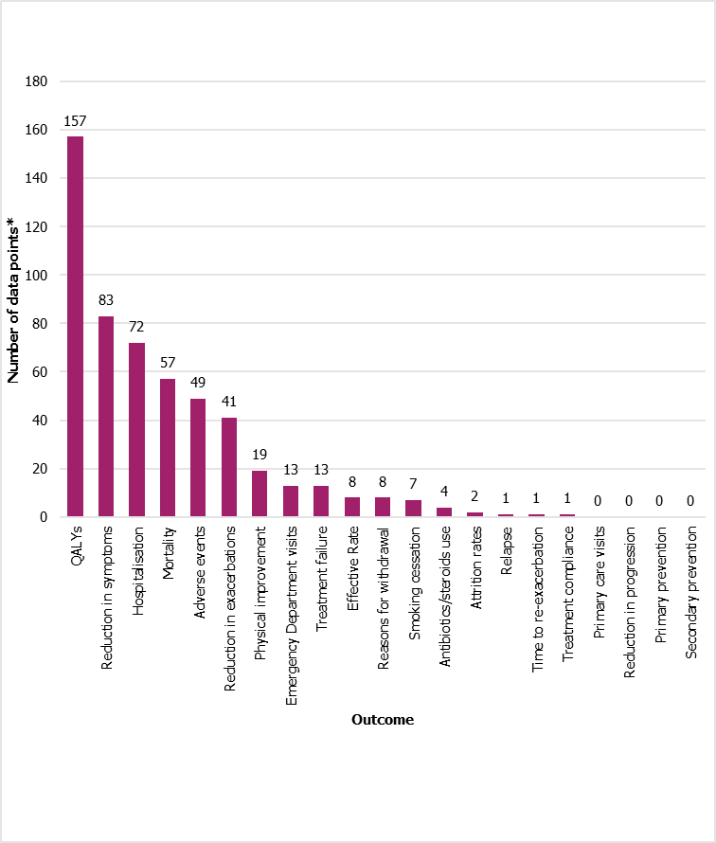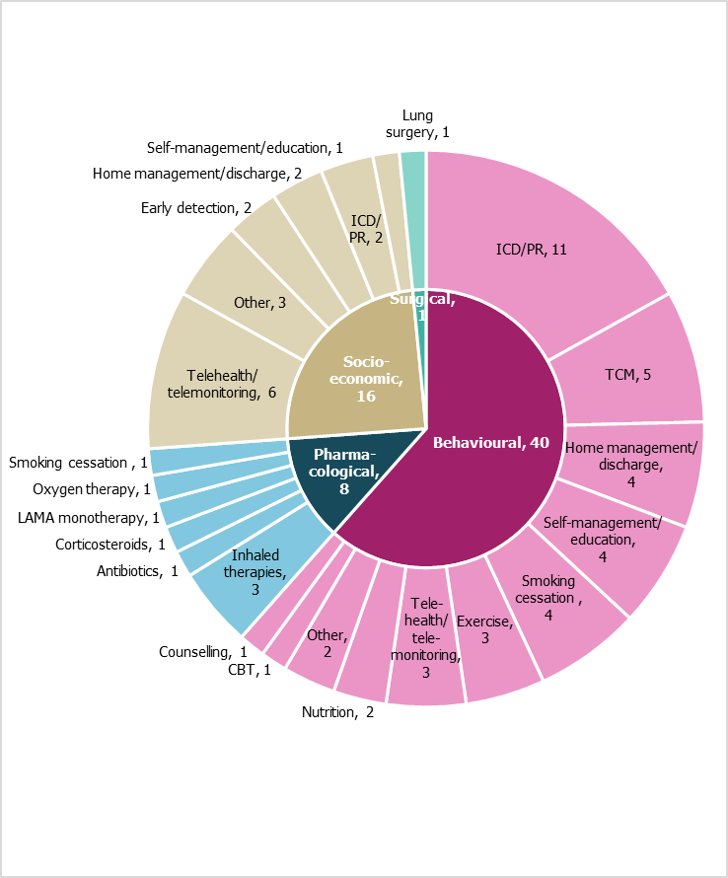

**A**

**B**

**Footnotes**: *Number of data points, i.e. if one study reported an outcome multiple times, this was counted each time. **Abbreviations**: CBT, cognitive behavioural therapy; LAMA, long-acting muscarinic antagonist; PR, pulmonary rehabilitation TCM, Traditional Chinese Medicine; QALY, quality-adjusted life-years.

Figure 3. Reported outcomes for (A) behavioural (B) socio-economic and (C) pharmacological/surgical interventions in studies reporting QALYs, NNT, RRs or ORs

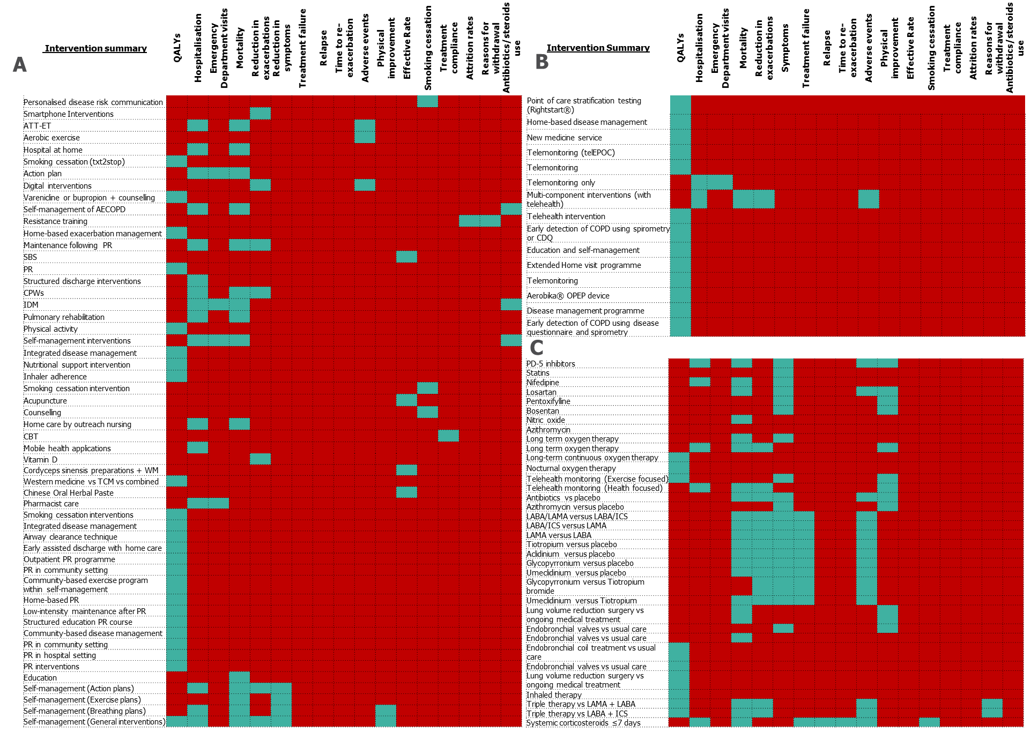

**Abbreviations**: AECOPD, acute exacerbations of COPD; ATT-ET, advanced telehealth technologies; CBT, cognitive behavioural therapy; CDQ, COPD Disease Questionnaire; COPD, chronic obstructive pulmonary disease; CPW, clinical pathways; ICS, inhaled corticosteroids; IDM, integrated disease management; LABA, long-acting beta-agonist; LAMA, long-acting muscarinic antagonist; OPEP, oscillating positive expiratory pressure; PR, pulmonary rehabilitation; WM, western medicine.

Figure 4. Reported RRs/ORs for hospitalisation

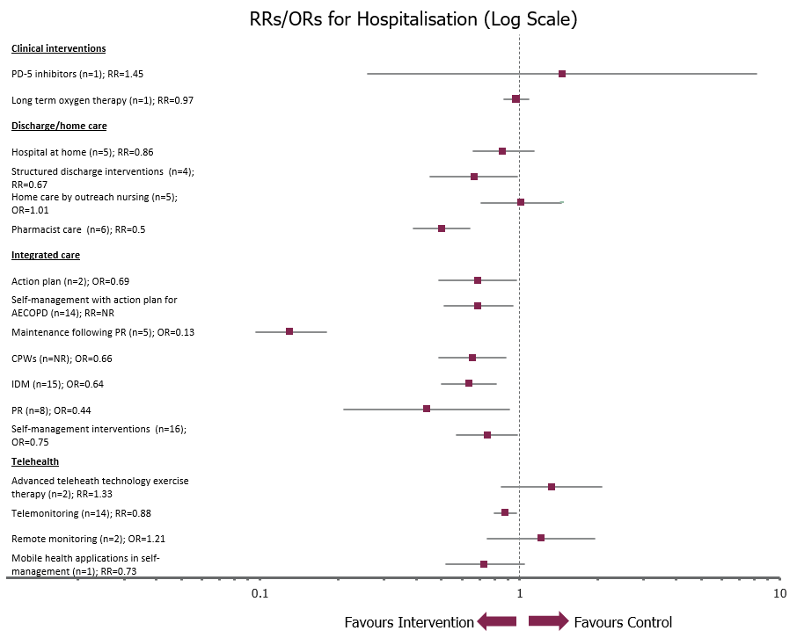

Summary forest plot includes ‘main’ analysis from each study only. For some studies, data for subgroups were also reported. Includes any hospitalisation, including all-cause, respiratory-related and readmissions. **Abbreviations**: AECOPD, acute exacerbations of COPD; COPD, chronic obstructive pulmonary disease; CPW, clinical pathways; IDM, integrated disease management; OR, odds ratio; PD-5, phosphodiesterase-5; PR, pulmonary rehabilitation; RR, risk ratio.

Figure 5. Reported RRs/ORs for emergency department visits

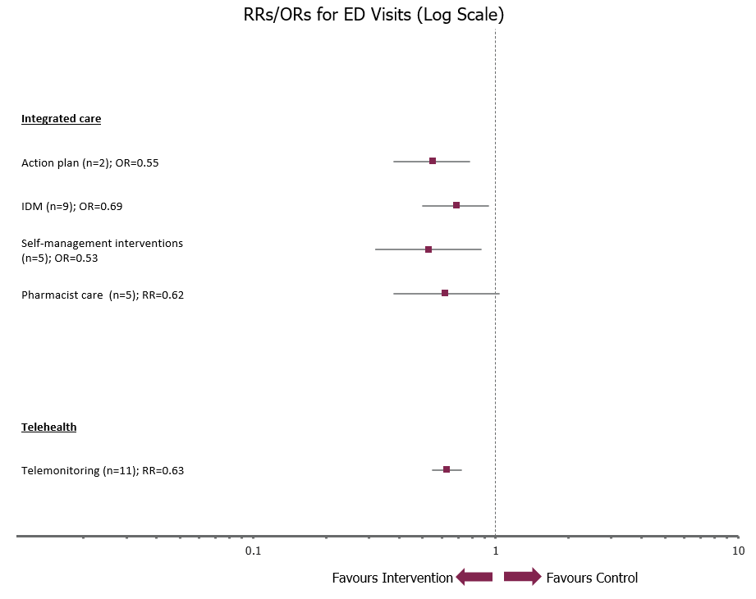

Forest plot includes ‘main’ analysis from each study only. For some studies, data for subgroups were also reported. **Abbreviations**: ED, emergency department; IDM, integrated disease management; OR, odds ratio; RR, risk ratio.

Figure 6. Reported RRs/ORs for mortality

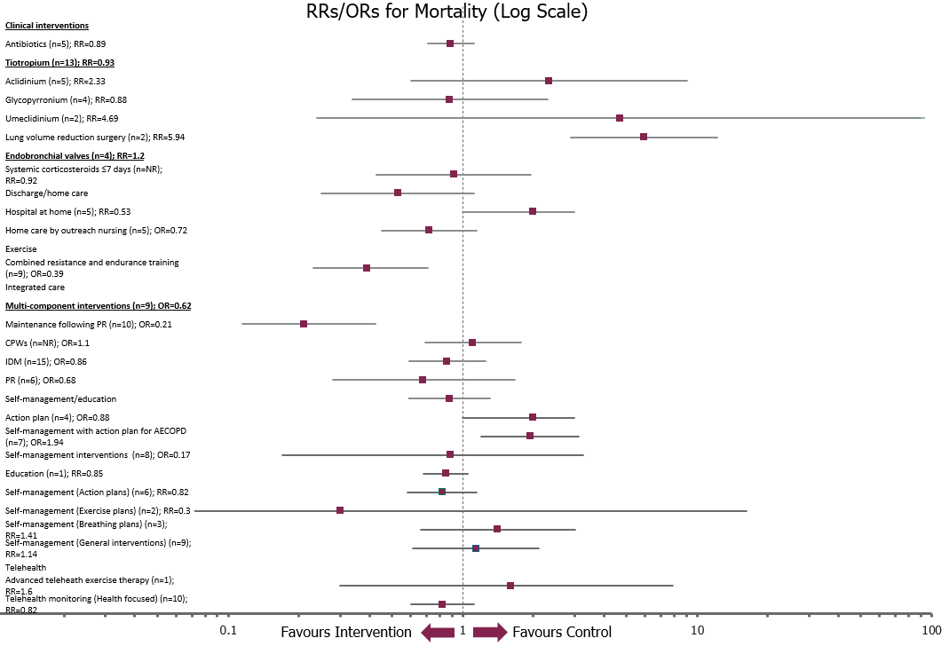

Summary forest plot includes ‘main’ analysis from each study only. For some studies, data for subgroups were also reported. Includes any mortality, including all-cause, respiratory-related. Also considers any timepoint. **Abbreviations**: AECOPD, acute exacerbations of COPD, COPD, chronic obstructive pulmonary disease; CPW, clinical pathways; IDM, integrated disease management; NR, not reported; OR, odds ratio; PR, pulmonary rehabilitation; RR, risk ratio.

Figure 7. Quality assessment A) AMSTAR-2 B) Drummond checklist of included studies reporting QALYs, NNT, RRs or ORs

1. **AMSTAR-2 for SLRs**

|  |  |  |  |  |  |  |  |  |  |  |  |  |  |  |  |  |  |  |  |  |  |  |  |  |  |  |  |  |  |  |  |
| --- | --- | --- | --- | --- | --- | --- | --- | --- | --- | --- | --- | --- | --- | --- | --- | --- | --- | --- | --- | --- | --- | --- | --- | --- | --- | --- | --- | --- | --- | --- | --- |
| Research question and inclusion criteria based on PICO? |  |  |  |  |  |  |  |  |  |  |  |  |  |  |  |  |  |  |  |  |  |  |  |  |  |  |  |  |  |  |  |
| Methods established prior to review and justification of significant deviations from protocol? |  |  |  |  |  |  |  |  |  |  |  |  |  |  |  |  |  |  |  |  |  |  |  |  |  |  |  |  |  |  |  |
| Explanation on selection of the study designs? |  |  |  |  |  |  |  |  |  |  |  |  |  |  |  |  |  |  |  |  |  |  |  |  |  |  |  |  |  |  |  |
| Literature search strategy? |  |  |  |  |  |  |  |  |  |  |  |  |  |  |  |  |  |  |  |  |  |  |  |  |  |  |  |  |  |  |  |
| Study selection in duplicate? |  |  |  |  |  |  |  |  |  |  |  |  |  |  |  |  |  |  |  |  |  |  |  |  |  |  |  |  |  |  |  |
| Data extraction in duplicate? |  |  |  |  |  |  |  |  |  |  |  |  |  |  |  |  |  |  |  |  |  |  |  |  |  |  |  |  |  |  |  |
| List of excluded studies and justification of exclusions? |  |  |  |  |  |  |  |  |  |  |  |  |  |  |  |  |  |  |  |  |  |  |  |  |  |  |  |  |  |  |  |
| Adequate detail of included studies? |  |  |  |  |  |  |  |  |  |  |  |  |  |  |  |  |  |  |  |  |  |  |  |  |  |  |  |  |  |  |  |
| RoB assessment of RCTs included in the review? |  |  |  |  |  |  |  |  |  |  |  |  |  |  |  |  |  |  |  |  |  |  |  |  |  |  |  |  |  |  |  |
| RoB assessment of non-RCTs included in the review? |  |  |  |  |  |  |  |  |  |  |  |  |  |  |  |  |  |  |  |  |  |  |  |  |  |  |  |  |  |  |  |
| Reporting of sources of funding for included studies? |  |  |  |  |  |  |  |  |  |  |  |  |  |  |  |  |  |  |  |  |  |  |  |  |  |  |  |  |  |  |  |
| Was quantitative synthesis of the results (e.g., via meta-analysis) performed? |  |  |  |  |  |  |  |  |  |  |  |  |  |  |  |  |  |  |  |  |  |  |  |  |  |  |  |  |  |  |  |
| Appropriate methods for statistical combination of results for meta-analysis of RCTs? |  |  |  |  |  |  |  |  |  |  |  |  |  |  |  |  |  |  |  |  |  |  |  |  |  |  |  |  |  |  |  |
| Appropriate methods for statistical combination of results for meta-analysis of non-RCTs? |  |  |  |  |  |  |  |  |  |  |  |  |  |  |  |  |  |  |  |  |  |  |  |  |  |  |  |  |  |  |  |
| Assessment of RoB in studies on the results of the meta-analysis or other evidence synthesis? |  |  |  |  |  |  |  |  |  |  |  |  |  |  |  |  |  |  |  |  |  |  |  |  |  |  |  |  |  |  |  |
| RoB consideration when interpreting/discussing the results of the review? |  |  |  |  |  |  |  |  |  |  |  |  |  |  |  |  |  |  |  |  |  |  |  |  |  |  |  |  |  |  |  |
| Explanation and discussion of heterogeneity? |  |  |  |  |  |  |  |  |  |  |  |  |  |  |  |  |  |  |  |  |  |  |  |  |  |  |  |  |  |  |  |
| Adequate investigation and discussion of publication bias? |  |  |  |  |  |  |  |  |  |  |  |  |  |  |  |  |  |  |  |  |  |  |  |  |  |  |  |  |  |  |  |
| Reporting of potential sources of CoI, including funding received for conducting the review? |  |  |  |  |  |  |  |  |  |  |  |  |  |  |  |  |  |  |  |  |  |  |  |  |  |  |  |  |  |  |  |
|  | **Alwashmi 2016** | **Bonnevie 2021** | **Chen 2021** | **Gonçalves-Bradley 2017** | **Hong 2019** | **Howcroft 2016** | **Janjua 2021a** | **Janjua 2021b** | **Kirsch 2015** | **Leemans 2021** | **Lenferink 2017** | **Liao 2015** | **Liu 2021** | **Malaguti 2021** | **Mao 2021** | **Pedersen 2017** | **Plishka 2019** | **Poot 2021** | **Puhan 2016** | **Schrjiver 2022** | **van Eerd 2016** | **Wang 2018** | **Williams 2017** | **Wong 2012** | **Xie 2020** | **Yang 2018** | **Yang 2022** | **Yu 2019** | **Zeng 2020** | **Zhong 2014** | **NICE 2019** |

|  |  |  |  |
| --- | --- | --- | --- |
| Yes | Partial yes | No | N/A |

1. **Drummond et al. checklist for economic evaluations**

|  |  |  |  |  |  |  |  |  |  |  |  |  |  |  |  |  |  |  |  |  |  |  |  |  |  |
| --- | --- | --- | --- | --- | --- | --- | --- | --- | --- | --- | --- | --- | --- | --- | --- | --- | --- | --- | --- | --- | --- | --- | --- | --- | --- |
| Research question stated? |  |  |  |  |  |  |  |  |  |  |  |  |  |  |  |  |  |  |  |  |  |  |  |  |  |
| Viewpoint stated and justified? |  |  |  |  |  |  |  |  |  |  |  |  |  |  |  |  |  |  |  |  |  |  |  |  |  |
| Rationale for choice of alternative interventions? |  |  |  |  |  |  |  |  |  |  |  |  |  |  |  |  |  |  |  |  |  |  |  |  |  |
| Alternatives clearly described? |  |  |  |  |  |  |  |  |  |  |  |  |  |  |  |  |  |  |  |  |  |  |  |  |  |
| Form of economic evaluation stated? |  |  |  |  |  |  |  |  |  |  |  |  |  |  |  |  |  |  |  |  |  |  |  |  |  |
| Source of effectiveness estimates stated? |  |  |  |  |  |  |  |  |  |  |  |  |  |  |  |  |  |  |  |  |  |  |  |  |  |
| Design and results of effectiveness study given? |  |  |  |  |  |  |  |  |  |  |  |  |  |  |  |  |  |  |  |  |  |  |  |  |  |
| Methods of synthesis or meta-analysis given? |  |  |  |  |  |  |  |  |  |  |  |  |  |  |  |  |  |  |  |  |  |  |  |  |  |
| Primary outcome measure clearly stated? |  |  |  |  |  |  |  |  |  |  |  |  |  |  |  |  |  |  |  |  |  |  |  |  |  |
| Methods to value health states stated? |  |  |  |  |  |  |  |  |  |  |  |  |  |  |  |  |  |  |  |  |  |  |  |  |  |
| Details of valuation subjects given? |  |  |  |  |  |  |  |  |  |  |  |  |  |  |  |  |  |  |  |  |  |  |  |  |  |
| Details of any model used given? |  |  |  |  |  |  |  |  |  |  |  |  |  |  |  |  |  |  |  |  |  |  |  |  |  |
| Justification for choice of model and key parameters? |  |  |  |  |  |  |  |  |  |  |  |  |  |  |  |  |  |  |  |  |  |  |  |  |  |
| Time horizon of cost and benefits stated? |  |  |  |  |  |  |  |  |  |  |  |  |  |  |  |  |  |  |  |  |  |  |  |  |  |
| Discount rate stated? |  |  |  |  |  |  |  |  |  |  |  |  |  |  |  |  |  |  |  |  |  |  |  |  |  |
| Choice of rate justified? |  |  |  |  |  |  |  |  |  |  |  |  |  |  |  |  |  |  |  |  |  |  |  |  |  |
| Explanation if cost or benefits were not discounted? |  |  |  |  |  |  |  |  |  |  |  |  |  |  |  |  |  |  |  |  |  |  |  |  |  |
| Details of statistical test/confidence intervals given? |  |  |  |  |  |  |  |  |  |  |  |  |  |  |  |  |  |  |  |  |  |  |  |  |  |
| Approach to sensitivity analysis described? |  |  |  |  |  |  |  |  |  |  |  |  |  |  |  |  |  |  |  |  |  |  |  |  |  |
| Choice of variables for sensitivity analysis justified? |  |  |  |  |  |  |  |  |  |  |  |  |  |  |  |  |  |  |  |  |  |  |  |  |  |
| Ranges over which parameters were varied stated? |  |  |  |  |  |  |  |  |  |  |  |  |  |  |  |  |  |  |  |  |  |  |  |  |  |
| Relevant alternatives compared? |  |  |  |  |  |  |  |  |  |  |  |  |  |  |  |  |  |  |  |  |  |  |  |  |  |
| Incremental analysis reported? |  |  |  |  |  |  |  |  |  |  |  |  |  |  |  |  |  |  |  |  |  |  |  |  |  |
| Outcomes presented disaggregated and aggregated? |  |  |  |  |  |  |  |  |  |  |  |  |  |  |  |  |  |  |  |  |  |  |  |  |  |
| Answer to the study question given? |  |  |  |  |  |  |  |  |  |  |  |  |  |  |  |  |  |  |  |  |  |  |  |  |  |
| Conclusions followed from data reported? |  |  |  |  |  |  |  |  |  |  |  |  |  |  |  |  |  |  |  |  |  |  |  |  |  |
| Conclusions accompanied by appropriate caveats? |  |  |  |  |  |  |  |  |  |  |  |  |  |  |  |  |  |  |  |  |  |  |  |  |  |
|  | **Abel 2019** | **Adamson 2022** | **Bourbeau 2019** | **Elliott 2017** | **Esteban 2021** | **Guerriero 2013** | **Hofer 2016** | **Jodar-Sanchez 2014** | **Johnson 2021** | **Khadour 2011** | **Kongsakon 2019** | **Lacasse 2022** | **Liu 2013** | **Mosher 2022** | **Ramos 2019** | **Sorensen 2018** | **Sorensen 2017** | **Stoddart 2015** | **Thanh 2019** | **Tsiachristas 2015** | **Tsiachristas 2014** | **van Beers 2020** | **van Bove 2018** | **Wright 2015** | **Yu 2019** |

|  |  |  |  |
| --- | --- | --- | --- |
| Yes | Partial yes | No | N/A |

Table 1. Summary of included studies reporting on NNTs, RRs or OR outcomes

| Author Year | Publication type | Included studies | Review question | Population | Total pooled sample size | Intervention: details | Comparator: details |
| --- | --- | --- | --- | --- | --- | --- | --- |
| Behavioural interventions | | | | | | | |
| Adamson 2022 | SLR and economic evaluation | 7 | To assess whether communication of personalised disease risk by GPs to smokers attending their practice is cost-effective for smoking cessation, through a cost-effectiveness analysis | Healthy smokers aged 35–60 attending a GP practice in England | 1099 | Communication of personalised disease risk (via established risk prediction tool) by GPs to smokers attending their practice for a separate reason | Usual care: NHS health checks programme (GP appointment for those aged 40–75, to receive an estimate of their CV risk and advice on risk reduction or interventions to lower modifiable risk factors) |
| Alwashmi 2016 | SLR | 6 (3 meta-analysis) | In patients diagnosed with COPD, will using smart phone interventions, compared with not using smart phone interventions, reduce the number of patients that have at least one exacerbation? | Patients with COPD as defined by GOLD | NR | Smartphone interventions: Questionnaires, tracking and recommendations of exercises, physiological monitoring, physician contact, treatment regime reminders | Usual care: No use of smartphones |
| Bonnevie 2020 | SLR | 15 | How effective is home-based exercise therapy delivered using advanced telehealth technology (ATT-ET) for people with COPD compared with no exercise therapy, in/outpatient exercise therapy, and home-based exercise therapy without advanced telehealth technology | People with stable COPD referred for exercise therapy | 1522 | Advanced telehealth technology exercise therapy: home-based pulmonary rehabilitation/ exercise therapy, using more advanced technology than phone contact alone | Other treatment: No intervention or in-patient/outpatient exercise therapy, or home-based exercise therapy without advanced telehealth technology |
| Chen 2021 | SLR | 18 | To provide a basis by which practitioners and therapists can select and create appropriate therapeutic programs | Patients with stable COPD | 1311 | Land and/or water-based aerobic exercise | Usual care: No further details reported |
| Gonçalves-Bradley 2017 | SLR | 5 | To determine the effectiveness and cost of managing patients with early discharge hospital at home compared with inpatient hospital care | Participants with COPD who are eligible to have received health care from an early discharge hospital at home service | 496 | Early discharge hospital at home: active treatment by HCPs in patient's home for condition that otherwise would require acute hospital inpatient care, always for a limited time period. The following services were not included as ‘hospital at home’: long-term care, services in outpatient or post-discharge settings, end-of-life care at home, patient self-care at home, e.g., self-administration of an IV infusion | Usual care: No further details reported |
| Guerriero 2013 | Economic evaluation | NA | To examine the cost-effectiveness of smoking cessation support delivered by mobile phone text messaging | Smokers aged 16 years or older | 5800 | Smoking cessation (txt2stop): Personalised smoking cessation advice and support by mobile phone message. Participants received five text messages per day for the first 5 weeks and three per week for the next 26 weeks | Current practice: Interventions currently available in the UK to help people stop smoking, including medication (NRT, bupropion, varenicline), telephone helpline, group or individual counselling |
| Howcroft 2016 | SLR | 7 | To compare effects of an action plan for COPD exacerbations provided with a single short patient education component and without a comprehensive self-management programme versus usual care | Patients with a clinical diagnosis of COPD based on spirometric criteria such as those of GOLD for persistent airflow limitation (i.e. postbronchodilator FEV1/FVC < 70%) with a history of smoking, individuals had an exacerbation of COPD | 1550 | Action plan with a single educational component of short duration, defined as a written or oral guideline that details self-initiated interventions (such as changing medication regimens or visiting a GP or hospital) undertaken in response to alterations in symptoms of COPD that would suggest commencement of an exacerbation | Usual care: No further details reported |
| Janjua 2019 | SLR | 14 | To assess benefits and harms of digital interventions for managing COPD and apply BCT taxonomy to describe and explore intervention content | Adult COPD patients diagnosed according to established criteria. Those with comorbidities were included, provided the intervention was aimed at managing the COPD | 1518 | SMS, Mobile phones, personal digital assistants, MP3, medical device connected to phone by cord or wirelessly, Smartphone applications or applications on a smart device, Web or Internet-based interventions | Routine supported self-management or usual care: No further details reported |
| Kirsch 2015 | SLR | 10 | To present a systematic review of Markov models evaluating the cost-effectiveness of smoking cessation interventions in COPD, to estimate the quality of the models and to investigate generally how the differences in models and data affect cost-effectiveness outcomes in the included studies | Patients with COPD | NR | Smoking cessation : Mixed, including nicotine gum, group therapy, counselling, nicotine replacement therapy, bupropion, hypothetical smoking cessation program, varenicline, Australian National Tobacco Campaign | Usual care: Mixed, including advise to stop smoking, 'usual care', placebo |
| Kongsakon 2019 | Economic evaluation | NA | To estimate cost-utility of smoking cessation intervention in COPD patients | COPD patients willing to quit smoking | NR | 1) Bupropion + hospital counselling 2) varenicline + hospital counselling: No further details reported | Nortriptyline + hospital counselling: No further details reported |
| Leemans 2021 | SLR | 11 | What is the cost-effectiveness of respiratory physiotherapy interventions for people with COPD? | People with COPD | 3261 | Respiratory physiotherapy interventions : Any skill performed by a respiratory physiotherapist Reported interventions were PR programmes, airway clearance techniques, integrated disease management program and early assisted discharge accompanied by physiotherapy intervention. 82% of the interventions were exercise training in combination with enhancing physical activity levels. | Standard of care or any other respiratory physiotherapy treatment: No further details reported |
| Lenferink 2017 | SLR | 21 | To evaluate self-management interventions including action plans for exacerbations versus usual care in patients with COPD | Patients with COPD according to the GOLD classification criteria | 3854 | Self-management interventions with written action plan for AECOPD: The self-management intervention needed to include formal training on how and when to use an action plan for AECOPD. This had to be an iterative process between patient and healthcare provider. It could also include other components that were directed to achieving behaviour change (e.g., smoking behaviour, exercise or physical activity). Action plan referred to specific behaviour to be initiated when respiratory symptoms deteriorated and needed to describe when, where and how one should act. PR or exercise classes offered in a hospital, rehabilitation centre or community-based setting were excluded. | Usual care : De facto routine clinical care |
| Liao 2015 | SLR | 18 | To evaluate the effects of resistance training on subjects with COPD | Subjects with stable moderate-to-very severe COPD without other lung diseases | 750 | Resistance training: Exercise duration of at least 4 weeks, resistance training alone or in combination with endurance training | Non-exercise or endurance exercise alone: No further details reported |
| Liu 2021 | SLR | 10 | To understand the cost-effectiveness of PR in different settings for COPD to provide economic evidence for decision-makers | Adults with COPD | NR | PR programmes: Not specified in eligibility criteria but detailed in results - included pulmonary rehabilitation vs usual care, community-based PR and home-based PR | Usual care or PR in a different setting: No further details reported |
| Liu 2013 | Economic evaluation | NA | To determine the viability and requirements of a wide range of new approaches to the care of COPD patients in the home, in the context of a hypothetical COPD exacerbation management program for which clinical data is not yet readily available | Patients with COPD, stratified by risk of exacerbation | NR | Hypothetical home-based exacerbation management: Conceptualised as having two primary components: 1) TEST: means to enable early exacerbation detection 2) TREAT: early treatment upon the detection of exacerbation | Usual care: No further details reported |
| Malaguti 2021 | SLR | 21 | To determine whether supervised pulmonary rehabilitation maintenance programmes improve HRQoL, exercise performance, and health care utilisation in COPD patients compared with usual care | Adults with a diagnosis of COPD who had undertaken a pulmonary rehabilitation programme | 1799 | Maintenance following pulmonary rehabilitation: Defined as supervised exercise training at a lower frequency than the initial pulmonary rehabilitation program, with or without other components such as education and self-management training. Supervision could be provided in-person or remotely. | Usual care or attention control: Attention control was defined as an additional contact with the patient, whereby the patient receives some aspect of attention, time or expectation (e.g. a telephone call), but without supervised training. Usual care was defined as standard treatment for COPD and did not involve a supervised exercise training programme |
| Mao 2021 | SLR | 10 | To determine whether the SBS used in the treatment of gastrointestinal disease was effective to treat COPD | Patients with stable COPD | 770 | Traditional Chinese Medicine: Shenling Baizhu San | Usual care: Salmeterol/fluticasone, tiotropium, aminophylline combined with ipratropium bromide |
| Mosher 2022 | Economic evaluation | NA | To estimate the cost-effectiveness of participation in PR after hospitalisation for COP | Medicare beneficiaries 65 years or older who were hospitalised for COPD in 2014 | NR | PR: No further details reported | No PR: No further details reported |
| Pedersen 2017 | SLR | 10 (6 in meta-analysis) | To identify, appraise and synthesise the best available evidence on the effectiveness of discharge interventions that can reduce readmission of patients with COPD | Hospitalised adult patients with COPD that had been admitted to hospital due to acute exacerbation | 1723 | Structured discharge interventions, such as: Screening patients with a high risk of post-discharge problems, Intensive in-hospital discharge preparation, Discharge rounds, Written information leaflets, Implementation of liaison nurses and discharge coordinators, Case management, Home visits prior to discharge, Preventive home visits of district nurses after discharge, Post-hospital support programs, Telephone follow-up after discharge, Discharge planning protocols, Improved communication between hospital and primary care providers, Tele-health care | Usual care : Contacting the GP via letter, phoning district nurses, dispensing of prescriptions and other tasks |
| Plishka 2019 | SLR | 10 | What are the effects of CPWs for COPD on patient-, professional-, and systems-level outcomes? | Patients with COPD | NR | CPWs in primary care and hospitals: No further details reported | Usual care: No further details reported |
| Poot 2021 | SLR | 52 | To compare the effectiveness of IDM programmes versus usual care for people with COPD in terms of HRQoL, exercise tolerance, and exacerbation-related outcomes. | Patients with COPD according to GOLD criteria | 21086 | Interventions consisted of multi‐disciplinary (two or more healthcare providers) and multi‐treatment (two or more components) IDM programmes of at least three months’ duration.: No further details reported | Usual care: No further details reported |
| Puhan 2016 | SLR | 20 | To assess effects of pulmonary rehabilitation after COPD exacerbations on hospital admissions (primary outcome) and other patient‐important outcomes (mortality, health‐related quality of life (HRQoL) and exercise capacity). | Participants with COPD after inpatient or outpatient care for acute exacerbation | 1477 | Pulmonary rehabilitation.: Pulmonary rehabilitation programmes had to include at least physical exercise (endurance or strength exercise, or both) | Usual care: No further details reported |
| Ramos 2019 | Economic evaluation | NA | To estimate the cost-effectiveness of regular physical activity vs sedentary lifestyle in people with COPD in the UK | Patients with COPD | 9219 (clinical data); 1235 (utility data) | Physical activity: Combination of three physical activity levels (low, moderate and high). Low = <2 hours/week; moderate = 2-4 hours/week; high = >4 hours/week | Sedentary lifestyle: Very low physical activity |
| Schrijver 2022 | SLR | 26 | To evaluate the effectiveness of COPD self-management interventions compared to usual care in terms of HRQoL and respiratory-related hospital admissions and to evaluate the safety of COPD self-management interventions compared to usual care in terms of respiratory-related mortality and all-cause mortality | Patients with COPD | 6008 | COPD exacerbation action plan, self-recognition of COPD exacerbations, home-based exercise or physical activity, coping with breathlessness, smoking cessation, diet: No further details reported | Usual care: No further details reported |
| Sorensen 2018 | Economic evaluation | NA | To examine the heterogeneity in cost-effectiveness analyses of patient-tailored complex interventions | Patients with COPD referred for pulmonary rehabilitation | 150 | Integrated disease management: Community-based case management + usual care (delivered by experienced nurse), comprising eight components: 1) instructions on how to prevent, detect and deal with acute exacerbations; 2) assessment of pharmacological treatment of COPD; 3) provision of dietary advice; 4) advice on smoking cessation/reduction; 5) preparation of appointments with other health personnel; 6) involvement of caregivers in the care plan; 7) support for psychological problems (e.g., anxiety, identity, relations); 8) support for social problems. | Usual care: No further details reported |
| Sorensen 2017 | Economic evaluation | NA | To analyse the cost-effectiveness of community-based case management for patients with COPD | Patients with COPD referred for pulmonary rehabilitation | 150 | Integrated disease management: Community-based case management + usual care (delivered by experienced nurse), comprising five components: 1) assessment of health risk and care planning; 2) monitoring of individual health status; 3) promotion of self-care and autonomy; 4) provision of COPD knowledge and support; 5) facilitation of relevant health and social services and coordination of care Intensity and focus of the intervention was based on individual participant needs and hence not homogenous | Usual care: No further details reported |
| Van Beers 2020 | Economic evaluation | NA | To investigate the clinical outcome and cost-effectiveness of a 12-month nutritional intervention strategy in muscle-wasted COPD patients. | COPD patients with muscle wastage, moderate airflow obstruction and impaired exercise capacity | 81 | Nutritional intervention strategy: Usual care, plus 3 portions of nutritional supplementation per day (including protein, carbohydrates, fat and micronutrients and enriched with leucine, vitamin D and polyunsaturated fatty acids), as well as one additional portion of supplemental nutrition per day and motivational interviewing-based nutritional counselling | Usual care: Supervised centre-based exercise training programme and patients were advised to consume 3 oral nutritional supplements daily |
| Van Boven 2018 | Economic evaluation | NA | To estimate the potential cost-effectiveness of reaching optimal adherence to maintenance therapy in each suboptimal adherence cluster. | Hospitalised COPD patients prescribed salmeterol/fluticasone propionate | 226 | Good inhaler technique and adherence: No further details reported | Poor inhaler technique or adherence: Including regular use but frequent critical technique errors, irregular use but good technique, and irregular use and frequent critical technique errors |
| Van Eerd 2016 | SLR | 16 | To evaluate the effectiveness of behavioural or pharmacological smoking cessation interventions, or both, in smokers with COPD | Smokers with a diagnosis of COPD, according to the criteria from the guidelines of the American Thoracic Society, the British Thoracic Society, or GOLD, or as confirmed by the treating physician | 13123 | Smoking cessation: Any form of behavioural or pharmacological treatment, or a combination of both, as an aid to smoking cessation in people with COPD. Behavioural treatment refers to any psychotherapeutic approach aimed at identifying and modifying the behaviours associated with smoking. A behavioural treatment was classed as high if any pre-scheduled counselling session of greater than 10 minutes was offered with at least one face-to-face counselling session. Otherwise the behavioural treatment was categorised as “low” | Usual care: Usual care, a different form of behavioural treatment, comparison of different combinations of behavioural and pharmacological treatments |
| Wang 2018 | SLR | 19 | To evaluate the efficacy and safety of acupuncture for improving functional effects and quality of life in COPD patients | Patients with COPD defined as a clinical diagnosis of COPD, with a postbronchodilator fixed ration of FEV1/FVC <0.70 measured by spirometry. Patients with acute exacerbation within four weeks before the study were excluded | 1298 | Acupuncture: Manual acupuncture, electroacupuncture and warm acupuncture | No further details reported: No further details reported |
| Williams 2017 | SLR | 22 | To describe and explore health counselling interventions for people with COPD | Adults with COPD with a physician or spirometric diagnosis of COPD or COPD/ asthma overlap irrespective of disease severity or comorbidities | NR | Counselling: One study provided a definition: confrontational counselling involves confronting smokers with the consequences of their addiction and uses specific communication skills to identify and challenge irrational beliefs about smoking | No further details reported: No further details reported |
| Wong 2012 | SLR | 9 | To evaluate the effectiveness of outreach respiratory health care worker programmes for COPD patients in terms of improving lung function, exercise tolerance and health related quality of life of patient and carer, and reducing mortality and medical service utilisation | COPD patients as defined according to pulmonary function test findings, consistent with the BTS criteria | 1498 | Home care by outreach nursing: Interventions comprising home visits by a respiratory nurse or similar respiratory health worker, to facilitate health care, provide education, provide social support, identify respiratory deteriorations promptly and reinforce correct technique with inhaler therapy | Patients who received routine care, without respiratory nurse/health worker input: No further details reported |
| Xie 2020 | SLR | 10 | To evaluate the effectiveness of CBT on patients with COPD | Adults with a confirmed diagnosis of COPD according to GOLD standard, patients with dyspnoea, chronic cough or sputum production, and a history of exposure to risk factors for the disease; FEV1/FVC < 0.70 after inhalation of bronchodilators confirms the presence of persistent airflow limitation. Stable patients (patients with cough, sputum, shortness of breath and other symptoms stable or lighter). Patients with normal verbal communication skills. | 1173 | Cognitive behavioural therapy | Standard methods of care: E.g. quitting smoking, preventing and controlling respiratory infection, nutrition guidance, pulmonary rehabilitation and self-management |
| Yang 2018 | SLR | 8 | To compare the efficacy of mobile phone intervention with usual care in self-management, in terms of hospital admissions and the lengths of hospitalisation | Patients with COPD | 391 | Mobile/smartphones: Mobile/smartphones with different software and measuring devices to support patients in recording and monitoring their own physiological status, such as oxygen saturation levels, pulse rates, pedometers, or blood pressure monitors; or health behaviours, such as medications and dietary intake and exercise levels | Usual care: No further details reported |
| Yang 2022 | SLR | 17 | To analyse the impact of vitamin D on COPD and to gain evidence-based basis to improve the dysfunctional state of COPD T cells. | Patients with COPD | 1598 | Vitamin D : Vitamin D alone or combined with conventional treatments, including oral calcitriol capsules, oral vitamin D, oral liquid calcium, and intramuscular vitamin D | Routine treatments: Oxygen therapy, physical exercise, oral theophylline preparations and ambroxol, glucocorticoids, and inhaled long-acting β2 receptor agonists |
| Yu 2019a | SLR | 13 | To evaluate the effect of Cordyceps sinensis in people with GOLD stage 2-3 COPD | Patients with GOLD stage 2-3 COPD | 1092 | Oral cordyceps sinensis preparations and its formulae: A preparation of cordyceps sinensis, such as Bai Ling Capsule and Jin Shui Bao Capsule, in which fermented cordyceps sinensis is the main component in the preparations beside other additional agents such as vitamin B1 and microelements, or a cordyceps sinensis formulae which combined cordyceps sinensis with other herbs | Routine care or western medicine (WM): Non-pharmacological respiratory therapies such as smoking cessation, pulmonary rehabilitation, oxygen therapy and pulmonary exercise. Studies including a wait list control or no treatment in the control arm were also included |
| Yu 2019b | Economic evaluation | NA | To evaluate the costs and utilities of different treatment strategies for stable COPD patients, including Western medicine, TCM and combined treatment | Patients with stable COPD aged 18−80 years. COPD could range from mild to very severe | 236 | TCM or combined treatment: Patients in the TCM group were treated with Chinese herbal medicine, Bufei granule, Bu-Fei Jian-Pi granule, Bu-Fei Yi-Shen granule and Yi-Qi Zi-Shen granule. Patients in the combined treatment group received an intervention of both Western and TCM medicine at the same time | Western medicine: Patients in the Western medicine group were divided into 4 groups and prescribed Salbutamol, Formoterol, Salmeterol/fluticasone |
| Zeng 2020 | SLR | 19 | To assess the clinical efficacy and safety of Chinese oral herbal paste in the treatment for stable COPD | Patients with stable COPD | 1303 | Chinese herbal paste: Chinese oral herbal paste + Western medicine | Western medicine: Western medicine + placebo, Western medicine alone |
| Zhong 2014 | SLR | 14 | To determine if pharmacist-care intervention provides a benefit in humanistic outcomes among patients with COPD | Adult outpatients with COPD | 1327 | Pharmacist care: Pharmacist-directed care and pharmacist-collaborative care, including educational interventions directed to patients, medication management, patient-reminder systems, smoking cessation program and feedback to healthcare professionals | Usual care: No further details reported |
| NG115[C] | SLR | 68 | What is the clinical and cost effectiveness of self-management interventions, education and telehealth monitoring for improving outcomes and adherence to treatment in people with stable COPD? | People diagnosed with COPD | NR | Self-management, education or telehealth monitoring: Self management interventions included structured interventions for individuals aimed at improvement in self-health behaviours and self-management skills; education was information provided to support broader knowledge of COPD; telehealth monitoring was defined as data and feedback from a health professional, including data on completion of exercise as well as health status | Other: Any intervention, no intervention (placebo, routine medical care, no treatment), combinations of interventions |
| Socioeconomic outcomes | | | | | | | |
| Abel 2019 | Economic evaluation | NA | To evaluate the cost-effectiveness of developing stratification testing for treatment of COPD in the primary care setting in the UK | COPD patients aged 60 years with COPD at GOLD stages II-IV, who have experienced exacerbations previously and have a self-rescue pack at home | NR | Point of care stratification test (Rightstart®) (and following treatment): Rightstart® uses a panel of biomarkers to distinguish between eosinophilic and bacterial exacerbations, and is designed to be used at home. It is then used in conjunction with advice from patient’s GPs to determine the optimal treatment at exacerbation onset. | Usual care: No further details reported |
| Bourbeau 2019 | Economic evaluation | NA | To evaluate the cost-effectiveness of a home-based disease management intervention vs usual management in patients from the COPD Patient Management European TRIAL (COMET) | COPD patients included in the COMET trial (NCT01241526) | 319 | Home-based disease management: Several components, including a self-management program and coaching by a case manager based on the “Living Well With COPD” program, home monitoring, and an e-Health telephone/web platform for prompt detection and early treatment of exacerbations | Usual management: No further details reported |
| Elliott 2017 | Economic evaluation | NA | To evaluate the cost effectiveness of the NMS compared with normal practice in changing medicine-taking behaviour, following published reporting criteria | Patients with COPD or asthma | 117 | New medicine service: NMS begins with the patient’s initial presentation with a prescription for a medicine that is new to them in a community pharmacy. The intervention consists of a one-to-one consultation 7–14 days later, with a follow-up 14–21 days after that, the whole episode lasting 5 weeks. The primary aim of the intervention, is the patient-centred identification of any problems with the treatment and provision of appropriate support or action | Normal practice: The pharmacist’s usual advice, with no planned follow-up |
| Esteban 2021 | Economic evaluation | NA | To explore the cost-effectiveness of applying a telemonitoring system to a cohort of COPD patients with frequent readmissions (the telEPOC programme). | COPD patients with a FVC/FEV1 <70% and a history of at least two admissions for exacerbation in the last year or at least three admissions in the last 2 years | 163 | Telemonitoring program (telEPOC): The programme consisted of 1) education about COPD addressed to patients and caregivers, 2) training in the use of the telemonitoring device and 3) daily phone calls to boost patients’ self-esteem during the first week of telemonitoring. Once patients were using all features of the telemonitoring system, calls were only made in the event of an emergency. | Usual care: No further details reported |
| Hofer 2016 | Economic evaluation | NA | To evaluate whether telemonitoring interventions for COPD are cost-effective from the perspective of the German statutory sickness funds | COPD patients with GOLD grade 3 and 4 | NR | Telemonitoring interventions: The patient transmits data about vital parameters to a network that is able to calculate the risk of exacerbations. The transmitted data can be accessed by a nurse or physician | Standard care: No further details reported |
| Hong 2019 | SLR | 27 | To analyse the effect of telemonitoring on COPD patients and to perform subgroup analysis by patient severity and intervention type | Patients with COPD | NR | Telemonitoring: Digital wireless transmission of physiological and other non-invasive data, such as a patient’s health symptoms | Control, usual care or no intervention: No further details reported |
| Janjua 2021 | SLR | 29 | To assess the effectiveness of telehealth interventions that allow remote monitoring and consultation and multi-component interventions for reducing exacerbations and improving quality of life, while reducing dyspnoea symptoms, hospital service utilisation, and death among people with COPD | ≥18 years, diagnosis of COPD according to established criteria (e.g. GOLD staging, ERS or ATS criteria), including adults with any comorbidities | 5654 | Telehealth interventions: Remote monitoring, remote consultation, or both, plus usual care. The following telehealth intervention categories were also included: wired or wireless tele-healthcare systems to monitor physiological parameters that are processed or authorised by healthcare professionals, store and forward tele-healthcare systems and internet-based telecommunication with healthcare professionals via video or telephone | Usual care alone: No further details reported |
| Jodar-Sanchez 2014 | Economic evaluation | NA | To estimate the incremental cost-effectiveness ratio of a telehealth programme compared with usual care | Patients with very severe COPD treated with long-term oxygen therapy | 45 | Teleheath: Patients measured their vital signs from Monday to Friday using a spirometer, a pulse oximeter, a heart rate and blood pressure monitor. The data were sent via a hub connected to the patient’s home telephone line. The information was then received by clinical call centre staff who used a triage application. When an alert was triggered, the clinical call centre staff contacted the patient to confirm the patient’s symptoms and gain more information about the severity of the exacerbation. After that the call centre staff contacted a case manager who analysed the vital sign measurements together with the clinical questionnaire responses, accessing the platform via a mobile telephony and initiating the clinical response | Usual care: Health-related quality of life questionnaires were administered at the beginning and end of the study during visits to patients’ homes by nursing personnel |
| Johnson 2021 | Economic evaluation | NA | To assess the cost-effectiveness of primary care-based detection strategies for COPD | Canadian patients ≥40 years at risk of COPD | NR | Early detection of COPD: Two types of case detection method were evaluated, a hand-held flow meter and the COPD diagnostic questionnaire (CDQ). Hand-held flow meters are used for performing screening spirometry and were assessed with and without prior administration of a bronchodilator. The CDQ evaluates patient symptoms and risk factors. A score cut off of ≥19.5, ≥17 and ≥16.5 was used in different scenarios. Patients meeting the scenario-specific threshold were referred to diagnostic spirometry | No case detection: No further details reported |
| Khdour 2011 | Economic evaluation | NA | To undertake a cost-utility analysis to establish the cost-effectiveness of a pharmacy-led education and self-management programme for COPD compared with usual care | Patients aged over 45 years with a confirmed diagnosis of COPD for at least 1 year and an FEV1 of 30-80% of the predicted normal value | 127 | Pharmacy-led education and self-management: 60 minute consultation with a hospital pharmacist at baseline; development of a customised action plan for acute exacerbations for each patient; 20 minute telephone calls at 3 and 9 months; 30 minute outpatient visits at 6 and 12 months. | Usual care: Attendance at hospital outpatient clinic at 6 and 12 months where patients received usual care from medical and nursing staff (including symptom assessment, spirometry and prescription of inhalers/medication where needed) |
| Lacasse 2022 | Economic evaluation | NA | To estimate the cost-effectiveness ration of an extended home visit maintenance program for oxygen-dependent COPD patients | COPD patients who are oxygen-dependent | NR | Extended Home Visit Programme: Intensive education intervention at the initiation of long-term oxygen therapy, followed by an extended follow-up period that aims toward home oxygen adherence | Usual care: No further details reported |
| Stoddart 2015 | Economic evaluation | NA | To explore the effect of telemonitoring on the overall use of healthcare resources, and to examine its cost effectiveness | COPD patients who had been admitted to hospital for exacerbation of COPD | 256 | Telemonitoring + usual care: Patients had telemonitoring equipment installed in their homes. This included a touch-screen interface with which participants were asked to complete a daily symptoms and medication use questionnaire from which a validated symptom score was generated. This information and the oxygen saturation and pulse rate were transmitted to the clinical team. If scores exceeded predefined and validated thresholds, patients were contacted by telephone and further clinical assessment was undertaken to enable a decision about further management | Usual care: Clinical care according to their sub-region of residence and in accordance with Lothian protocols which were based on national and international guideline recommendations. Each participant also received education on self-management of exacerbations, reinforced by a copy of a booklet “Living with COPD”, which included a written management plan |
| hat 2019 | Economic evaluation | NA | To estimate the cost-effectiveness of the Aerobika® OPEP device among post-exacerbation COPD patients in the Canadian healthcare system | COPD patients who had recently experienced an exacerbation | NR | Aerobika® OPEP device: A hand-held medical device | Usual care: No further details reported |
| Tsiachristas 2015 | Economic evaluation | NA | To provide evidence about the (cost-)effectiveness of Dutch disease management programs (DMPs) as implemented in daily practice | COPD patients with mild to moderate COPD severity | NR | Most comprehensive disease management programme: The DMP included the following components: organisational support (integrated financing, specific subsidies for foreign population, sustainable financing agreements with health insurers), community (cooperation with external community partners, multidisciplinary and integrated collaboration, treatment and care pathways in outpatient and inpatient care, involvement of patient groups and patient panels in care design, regional training course, family participation), self-management (promotion of disease specific information, individual care plan, life-style interventions, personal coaching, motivational interviewing, informational meetings, diagnosis and treatment of mental health issues, group sessions for patient and family), decision support (care standards/clinical guidelines, uniform treatment protocol in outpatient and inpatient care, training and independence of practice assistants, professional education and training for care providers, automatic measurement of process/outcome indicators, audit and feedback, periodic evaluation of interventions and goal achievement, structural participation in knowledge exchange, quality of life questionnaires, qualitative evaluation of health care via focus groups with patients, measurement of patient satisfaction), delivery system design (delegation of care from specialist to nurse practitioner, substitution of inpatient with outpatient care, systematic follow-up of patients, meetings of different disciplines for exchanging knowledge/information, monitoring of high-risk patients, board of clients, periodic discussion sessions between care professionals), clinical information systems ( hospital or GP information system, use of ICT for internal or regional benchmarking, create a safe environment for data exchange, exchange of information between different care disciplines) | Least comprehensive disease management programme: The DMP included the following components: organisational support (integrated financing, sustainable financing agreements with health insurers), community (Cooperation with external community partners, Multidisciplinary and integrated collaboration, Treatment and care pathways in outpatient and inpatient care, Regional training course), Self-management (Life-style interventions, motivational interviewing), decision support (care standards, training and independence of practice assistants, Professional education and training for care providers, Automatic measurement of process/outcome indicators, Audit and feedback, Periodic evaluation of interventions and goal achievement, Structural participation in knowledge exchange/best practices, Quality of Life questionnaire), delivery system design (Delegation of care from specialist to nurse/care practitioner, Substitution of inpatient with outpatient care, Expansion of chain care to the secondary care setting, Meetings of different disciplines for exchanging knowledge/information, Monitoring of high-risk patients, Periodic discussion sessions between care professionals), clinical information systems (Hospital or General practice Information System, Integrated Information System, Use of ICT for Internal and/or regional benchmarking, Create a safe environment for data exchange, Systematic registration by every caregiver, Exchange of information between different care disciplines) |
| Tsiachristas 2014 | Economic evaluation | NA | To investigate the changes in costs and outcomes after the implementation of various disease management programs (DMPs), to identify their potential determinants, and to compare the costs and outcomes of different DMPs | COPD patients | NR | Most effective disease management programme: The DPM included the following components: decision support (care standards), clinical information systems (Hospital or General practice Information System) | Least effective disease management programme: The DPM included the following components: organisational support (specific subsidies for foreign population), community (involvement of patient groups and patient panels in care design), self-management (promotion of disease specific information, individual care plan, life-style interventions, personal coaching, motivational interviewing, diagnosis and treatment of mental health issues), decision support (care standards/clinical guidelines, training and independence of practice assistants, professional education and training for care providers, automatic measurement of process/outcome indicators, audit and feedback, quality of life questionnaires, qualitative evaluation of health care via focus groups with patients, measurement of patient satisfaction), delivery system design (delegation of care from specialist to nurse practitioner, systematic follow-up of patients), joint consultation hours (meetings of different disciplines for exchanging knowledge/information, monitoring of high-risk patients, board of clients, periodic discussion sessions between care professionals), clinical information systems ( hospital or GP information system, use of ICT for internal or regional benchmarking, create a safe environment for data exchange, exchange of information between different care disciplines) |
| Wright 2015 | Economic evaluation | NA | To pilot a community pharmacy COPD case finding service in England, estimating costs and effects | Patients potentially at risk of COPD (identified as either smokers or regular purchasers of cough medicine) | 238 | Early detection of COPD: Screening people at risk of COPD using a symptom questionnaire and spirometry test to evaluate lung function. The symptom questionnaire assessed patient age >35, whether patients smoked at least 100 in their life, number of times short of breath in previous four weeks, whether they ever cough up mucus or phlegm, and whether breathing problems affect usual activities. With each response graded out of 2, a score of >5 resulted in a GP referral. Micro-spirometry was used to determine FEV at 1 and 6 seconds. An FEV1 to FEV6 ratio of less than 0.7 or FEV <80% also resulted in a GP referral | Usual care: No further details reported |
| Pharmacologic/Surgical Outcomes | | | | | | | |
| NG115[A] | SLR | 4 | What are the most clinically and cost-effective therapies for managing complications (pulmonary hypertension and cor pulmonale) in people with stable chronic obstructive pulmonary disease (COPD)? | People diagnosed with COPD, and with pulmonary hypertension or cor pulmonale | NR | Smoking cessation, Statins or other lipid modifying drugs, Bosentan, Phosphodiesterase-5 (PD-5) inhibitors (including sildenafil), Beta blockers, Non-invasive ventilation: No further details reported | Each other or No intervention: No further details reported |
| NG115[B] | SLR | 4 | What is the effectiveness of oxygen therapy in people with stable COPD who are mildly hypoxaemic or non-hypoxaemic at rest? | People diagnosed with COPD who are mildly hypoxaemic or non-hypoxaemic at rest (PaO2 > 7.3 kPa) and do not receive long term oxygen therapy | NR | Oxygen therapy: No further details reported | Usual therapy: Air delivered by non-invasive method, optimal medical therapy |
| NG115[E] | SLR | 16 | What is the clinical and cost-effectiveness of prophylactic oral antibiotics for preventing exacerbations in people with stable COPD? | People diagnosed with COPD | NR | Oral antibiotics for prophylaxis: No further details reported | Placebo: No further details reported |
| NG115[F] | SLR | 5 | In people with stable COPD, what is the clinical and cost effectiveness of a LAMA + LABA compared with a LAMA alone, a LABA alone and LABA+ICS? | Patients aged >35 years, with a COPD diagnosis as per ATS/ERS, GOLD or equivalent criteria and at least moderate obstructive ventilator defect (FEV1 <80% predicted) | NR | Inhaled therapies: LAMA, LABA, LAMA+LABA, LABA+ICS | Inhaled therapy: LAMA, LABA, LAMA+LABA, LABA+ICS |
| NG115[F] | SLR | 5 | In people with stable COPD, what is the clinical and cost effectiveness of a LAMA + LABA compared with a LAMA alone, a LABA alone and LABA+ICS? | Patients aged >35 years, with a COPD diagnosis as per ATS/ERS, GOLD or equivalent criteria and at least moderate obstructive ventilator defect (FEV1 <80% predicted) | NR | Inhaled therapies: LAMA, LABA, LAMA+LABA, LABA+ICS | Inhaled therapy: LAMA, LABA, LAMA+LABA, LABA+ICS |
| NG115[G] | SLR | 23 | In patients with stable COPD, what are the referral criteria for lung surgery including lung volume reduction procedures, bullectomy and lung transplantation? | People diagnosed with COPD | NR | Lung surgery: Lung volume reduction surgery, bronchoscopic lung volume reduction, bullectomy, lung transplantation | Non-surgical treatment: No intervention, optimal medical therapy (pulmonary rehabilitation) |
| NG115[H] | Economic evaluation | NA | In people with stable COPD, what is the clinical and cost effectiveness of LAMA + LABA compared with LAMA alone, LABA alone or LABA + ICS? | Adults diagnosed with COPD | NR | Inhaled therapy: LAMA to LAMA+LABA | Inhaled therapy: LAMA to LABA+ICS, LAMA+LABA, LABA to LAMA+LABA, LABA to LABA+ICS or LABA+ICS |
| NG115[I] | SLR | 16 | In patients with stable COPD, what is the clinical and cost-effectiveness of LAMA + LABA + ICS compared with LAMA + LABA and LABA + ICS? | COPD patients >35 years old, with diagnosis of COPD in accordance with ATS/ERS, GOLD, or equivalent criteria and at least moderate obstructive ventilator defect (FEV1 <80% predicted) | NR | Inhaled triple therapy: LAMA + LABA + ICS | Inhaled double therapy: LAMA + LABA, LABA + ICS |
| NG115[J] | SLR | 5 | Are shorter durations of ≤ 7 days of corticosteroid treatment effective at treating acute exacerbations in people with COPD compared to longer treatments of > 7 days? | Adults with an acute exacerbation of COPD. The definition of an acute exacerbation could include any combination of an increase in breathlessness, sputum volume, sputum purulence, cough or wheeze. | 503 | Systemic corticosteroid given for a period of seven or fewer days: No further details reported | Systemic corticosteroids given for longer than seven days: No further details reported |

**Abbreviations**: COPD, chronic obstructive pulmonary disease; CPW, clinical pathways; CV, cardiovascular; GOLD, Global Initiative for Chronic Obstructive Lung Disease; FEV, forced expiratory volume; GP, general practitioner; HCP, health care practitioner; IDM, integrated disease management; IV, intravenous; NHS, National Health Service; NRT, nicotine replacement therapy; PR, pulmonary rehabilitation; SLR, systematic literature review;

Table 2. Summary of included studies reporting on outcomes other than NNTs, ORs or RRs

| Author Year | Publication type | Intervention details | Outcomes reported | Pooled outcomes (via meta-analysis?) | Overall rating of results |
| --- | --- | --- | --- | --- | --- |
| Behavioural interventions | | | | |  |
| Exercise-promoting interventions | | | | | |
| Cramer 2019 | SLR | Yoga | QoL, Dyspnoea, exercise capacity, FEVI, Safety | Y | **Improved outcomes** |
| Han 2021 | SLR | Step-counter based physical activity promotion | Physical activity, exercise capacity, Dyspnoea, QoL | N | **Improved outcomes** |
| McNamara 2013 | SLR | Water-based exercise training | Functional exercise capacity (6MWT), Peak exercise capacity (ISWT), Endurance exercise capacity (ESWT) QoL (SGRQ) | Y | **Improved outcomes** |
| Li 2022 | SLR | Chinese exercise, including Taijiquan (TJQ), Baduanjin (BDJ), Liuzijue (LZJ), Wuqinxi (WQX), and Yijinjing (YJJ | Lung function, 6MWT | N | **Trending positive, mixed results** |
| Liu 2021 | SLR | Tai chi | Exercise capability (6MWD), Lung function (FEV) | Y | **Trending positive, mixed results** |
| Wu 2018 | SLR | Meditative movement | 6MWD, FEV1, FVC, dyspnoea, fatigue | Y | **Trending positive, mixed results** |
| Music therapy or breathing techniques | | | | | |
| Huang 2021 | SLR | Music therapy (mixed/passive) | Dyspnoea, QoL, sleep quality, breathing frequency | Y | **Improved outcomes** |
| Yang 2022b | SLR | Pursed lip breathing combined with diaphragmatic breathing | FEV1, FVC, FEV1/FVC, 6MWT, | Y | **Improved outcomes** |
| Yun 2021 | SLR | Breathing exercises | PImax, PEmax, Borg scale, 6MWT, QoL (SGRQ), CAT | Y | **Improved outcomes** |
| Mayer 2018 | SLR | Acute use of pursed-lips breathing during exercise | exercise performance, dyspnoea, respiratory parameters, oxygen saturation, and arterial blood gases | Y | **Trending positive, mixed results** |
| Panigrahi 2014 | SLR | Singing, listening to music, Playing music | FVC, FEV, Pulse/respiratory rate, breathing control, dyspnoea, QoL | Y | **Trending positive, mixed results** |
| McNamara 2017 | SLR | Singing | HRQoL (respiratory specific and generic), dyspnoea | Y | **Unclear/insufficient evidence** |
| Smoking cessation | | | | | |
| Bartlett 2014 | SLR | Evaluation of psychological smoking cessation techniques | Average quit rate | N | **Improved outcomes** |
| Frazer 2016 | SLR | Smoking Bans | Rates of hospital admissions, hospital discharges | N | **Improved outcomes** |
| Hajat 2022 | SLR | E-cigarettes | Respiratory symptoms, disease progression, number of COPD exacerbations per year, lung function, exercise capacity, | N | **Trending positive, mixed results** |
| Traditional Chinese Medicine and holistic interventions | | | | | |
| Alsaeedi 2021 | SLR | Kinesiotaping | 6MWD, FEV, Dyspnoea | N | **Improved outcomes** |
| Alves 2022 | SLR | Neuromuscular electrical stimulation of the lower limbs | 6MWT, Muscle strength | Y | **Improved outcomes** |
| Polastri 2018 | SLR | Magnetic stimulation therapy | Motor function (6MWD, Vastus lateralis type I fibres size, Quadriceps TwQ and MVC, quadriceps endurance ), QoL (SF-36), SGRQ, Lung function-related parameters (FVC, FEV1, Tiffeneau index, PEF) | N | **Improved outcomes** |
| Zhang 2018 | SLR | Physiotherapy techniques: transcutaneous electric nerve stimulation, high frequency chest wall oscillatory ventilation, glottis opened in lateral position | Effectiveness (all and stratified), 6MWD, constant work test | Y | **Improved outcomes** |
| Zhou 2018 | SLR | Whole body vibration | 6MWD, FEV | Y | **Improved outcomes** |
| Galletti 2018 | SLR | Manipulative therapy | FEV1, 6MWT | Y | **Trending positive, mixed results** |
| Zhong 2014 | SLR | Yupingfen formula | FEV, 6MWD | Y | **Trending positive, mixed results** |
| Baxter 2019 | SLR | Muscle energy technique | 6MWT, FEV | N | **Unclear/insufficient evidence** |
| Huang 2021 | SLR | Acupoint autohemotherapy | 6MWD, FEV | Y | **Unclear/insufficient evidence** |
| Lou 2021 | SLR | Moxibustion (TCM) | Number of acute exacerbations, lung function, 6MWD, breathing questionnaire | N | **Unclear/insufficient evidence** |
| Raguckas 2016 | SLR | Osteopathic manual medicine (OMM) | Objective pulmonary measures | N | **Unclear/insufficient evidence** |
| Diet and supplementation | | | | | |
| Alshafie 2021 | SLR | Beetroot juice | Heart strength, 6MWT | Y | **Trending positive, mixed results** |
| Furulund 2021 | SLR | Diet (orally administered non-micronutrients based nutritional interventions - various) | Pulmonary function, physical function, HRQoL, inflammatory markers | N | **Trending positive, mixed results** |
| Yang 2022a | SLR | Nitrate supplementation | Exercise endurance time, exercise capacity, | N | **No change** |
| Aldahir 2020 | SLR | Nutritional supplements | Muscle function, physical activity, 6MWT | N | **Unclear/insufficient evidence** |
| Atlantis 2016 | SLR | Diet, intake of omega-3/6 fatty acids | Inflammatory markers, muscle strength, health status, HRQoL | N | **Unclear/insufficient evidence** |
| Atlantis 2013 | SLR | Testosterone supplementation therapy | Peak muscle strength and peak cardiorespiratory fitness outcomes, HRQoL | Y | **Unclear/insufficient evidence** |
| Inhaler technique education | | | | | |
| van de Hei 2021 | SLR | Test of Adherence to Inhalers toolkit | Adherence, usability | N | **Improved outcomes** |
| Maricoto 2019 | SLR | Inhaler technique review, self management, functional control | Inhaler performance, exacerbation rate, QoL, FEV1, Disease control, Adherence | Y | **Trending positive, mixed results** |
| Miscellaneous | | | | | |
| Dickens 2014 | SLR | Education, discussion, skills, exercise, behaviour therapy, relapse prevention, problem solving, CBT, increased social support, relaxation therapy | Unscheduled use of urgent care | Y | **Improved outcomes** |
| Farver-Vestergaard 2015 | SLR | Psychosocial (broad) | Anxiety and depression, lung function, dyspnoea, exercise capacity and fatigue, QoL | Y | **Improved outcomes** |
| Lee 2015 | SLR | Auditory stimuli | 6MWT, dyspnoea | Y | **Improved outcomes** |
| Lee 2018 | SLR | Impact of rollators | 6MWT, HRQoL, dyspnoea | Y | **Trending positive, mixed results** |
| Apessos 2021 | SLR | Periodontal therapy | QoL, Lung function, frequency of COPD exacerbations | N | **Unclear/insufficient evidence** |
| Socio-economic interventions | | | | | |
| Parekh 2019 | SLR | Community health worker interventions | Mini Asthma related quality of life scores, minimal clinically important difference, symptom-free days, physical activity, asthma management, urgent healthcare episodes, days of missed work | N | **Trending positive, mixed results** |
| Noonan 2019 | SLR | Involvement of caregivers in self management interventions | HRQoL | Y | **No change** |
| Environmental interventions | | | | | |
| Janjua 2021 | SLR | Pollution exposure reduction | Physiological markers of air pollution, healthcare usage, symptoms (not specific to COPD) | N | **Unclear/insufficient evidence** |

**Abbreviations:** 6MWD/6MWT: 6-metre walking distance/test; COPD, chronic obstructive pulmonary disease; FEV, forced expiratory volume; FVC, forced vital capacity; HRQoL, health-related quality of life; ISWT, incremental shuffle walk test; N, No; PEF, peak expiratory flow; SGRQ, St. George’s Respiratory Questionnaire; SLR, systematic literature review; TCM, traditional Chinese medicine; Y,

Table 3. NNT reported for behavioural and socio-economic interventions preventing hospitalisations

|  |  |  |
| --- | --- | --- |
| **Study** | **Intervention description** | **NNT** |
| Howcroft 2016 | Action plan detailing self-initiated interventions undertaken in response to alterations in COPD symptoms | **19** |
| Lenferink 2017 | Self-management intervention including formal training on how and when to use an action plan for AECOPD | High baseline risk of exacerbation over 12 months of follow-up: **12** |
| Low baseline risk of exacerbation over 12 months of follow-up: **17** |
| Pedersen 2017 | Structured discharge | 180 days follow-up: **29** |
| 360 days follow-up: **4.5** |
| Poot 2021 | Integrated disease management consisting of multidisciplinary and multi-treatment components of at least 3 months’ duration | **15** |
| Schrijver 2022 | Action plan including self-recognition of COPD exacerbations, home-based exercise, coping with breathlessness, smoking cessation and diet | High baseline risk of respiratory-related hospital admissions: **15** |
| Low baseline risk of respiratory-related hospital admissions: **26** |

**Abbreviations**: AECOPD, acute exacerbations of COPD; COPD, chronic obstructive pulmonary disease; NNT, number needed to treat

Table 4. Summary of reported QALYs of behavioural, socio-economic and pharmacological/surgical interventions

|  |  |  |
| --- | --- | --- |
| **Intervention category** | **Intervention vs comparator** | **QALY** |
| **Behavioural interventions** | | |
| **Smoking cessation** | Txt2stop/usual care | 0.029* |
| Varenicline + counselling vs nortriptyline + counselling | 0.11 |
| Bupropion + counselling vs nortriptyline + counselling | 0.005 |
| Hypothetical smoking cessation program vs usual care | 0.679 |
| Intensive counselling vs usual care | 0.58 |
| Nicotine replacement therapy vs usual care | 0.31 |
| Intensive counselling + nicotine replacement therapy vs placebo | 0.13 |
| Bupropion vs placebo | 0.13 |
| Minimal counselling vs usual care | 0.14 |
| Nicotine gum + group therapy vs advise to stop smoking | 0.04 |
| **Pulmonary rehabilitation** | PR vs no PR | 0.12 |
| Outpatient PR vs usual care | 0.03 |
| PR in community setting vs PR in hospital setting | -0.03 |
| Community-based exercise + self-management vs self-management | 0.04 |
| Home-based PR vs centre-based or outpatient group-based PR | 0.025 |
| Low-intensity maintenance course after PR vs standard care | 0.015 |
| Structured education PR course vs standard care | 0.002 |
| Interdisciplinary community-based management course vs usual care | 0.08 |
| Community-based PR with telephone follow-up vs community-based PR | 0.07 |
| Hospital-based PR with telephone follow-up vs hospital-based PR | -0.01 |
| PR vs usual care | 0.09 |
| Hospital-based PR vs usual care | 0.0062 |
| Home-based PR vs usual care | 0.0101 |
| Hospital-based + home-based PR vs usual care | 0.0353 |
| Telerehabilitation vs conventional rehabilitation | 0.013 |
| **Inhalation and oxygen** | Aerobika® OPEP device vs no PEP therapy | 0.04 |
| Inhaler adherence (good adherence and technique vs poor adherence and technique) | 0.038* |
| **Physical intervention** | Physical activity vs sedentary lifestyle | 0.662 |
| Airway clearance technique + advice vs advice only | -0.002 |
| **Diagnostic** | Communication of personalised disease risk vs usual care | 0.048* |
| **Disease management** | Hypothetical home-based exacerbation management vs usual care | 0.4 |
| Integrated disease management vs usual care | -0.0387 |
| Most comprehensive DMP vs Least comprehensive DMP | 0.002* |
| Most effective DMP vs least effective DMP | 0.009 |
| **Miscellaneous** | Additional nutritional support + exercise scheme vs No additional nutritional support + exercise scheme | 0.025 |
| Combined western medicine and TCM vs Western medicine | 0.31 |
| **Socioeconomic interventions** | | |
| **Home-based management** | Point of care (at home) bacterial testing vs usual care | 0.15 |
| Home-based disease management vs usual management | 0.099 |
| Extended home visit programme vs usual care | 0.048* |
| Usual inpatient hospital treatment vs early assisted discharge with home care | 0.005 |
| **Telemonitoring** | telEPOC vs usual care | -0.07 |
| Telemonitoring vs standard care | 0.05 |
| Telehealth vs usual care | 0.0053 |
| Telemonitoring vs usual care | 0.0167 |
| **Community-based pharmacy management** | New medicine service vs usual care | 0.14 |
| **Diagnostic** | Early detection of COPD using spirometry or CDQ vs no case detection | -0.046 |
| Early detection of COPD using CDQ and spirometry vs usual care | 0.22* |
| **Education and self-management** | Education and self-management vs usual care | 0.065 |
| **Pharmacologic or Surgical interventions** | | |
| **Surgical treatment** | Endobronchial coil vs usual care | 0.038 |
| Endobronchial valves vs medical management | 0.41 |
| Lung volume reduction surgery vs best medical care | 0.21 |
| **Oxygen therapy** | Long-term continuous oxygen therapy vs no oxygen therapy | 0.28 |
| Nocturnal oxygen therapy vs no oxygen therapy | 0.0125 |
| **Inhaled therapies** | LAMA to LABA+ICS vs LAMA to LAMA+LABA | -0.029 |
| LAMA + LABA vs LAMA to LAMA+LABA | 0.077 |
| LABA to LAMA + LABA vs LAMA to LAMA+LABA | -0.097 |
| LABA to LABA+ICS vs LAMA to LAMA+LABA | -0.126 |
| LABA+ICS vs LAMA to LAMA+LABA | -0.04 |
| **Triple therapy** | Triple therapy vs LAMA + LABA | 0.03 |
| Triple therapy vs LABA + ICS | 0.05 |

**Abbreviations**: CDQ, COPD Diagnostic Questionnaire; COPD, chronic obstructive pulmonary disease; DMP, disease management program; LABA, long acting beta agonist; ICS, inhaled corticosteroid; LAMA, long acting muscarinic antagonist; (O)PEP, (oscillating) positive expiratory pressure; PR, pulmonary rehabilitation; QALY, quality-adjusted life year

REFERENCES

1. Cramer H, Haller H, Klose P, et al. The risks and benefits of yoga for patients with chronic obstructive pulmonary disease: a systematic review and meta-analysis. Clinical rehabilitation 2019;33(12):1847-1862.

2. Wu LL, Lin ZK, Weng HD, et al. Effectiveness of meditative movement on copd: A systematic review and meta-analysis. International Journal of COPD 2018;13:1239-1250.

3. Liu X, Fu C, Hu W, et al. The effect of Tai Chi on the pulmonary rehabilitation of chronic obstructive pulmonary disease: a systematic review and meta-analysis. Annals of palliative medicine 2021;10(4):3763-3782.

4. Li L, Huang H, Song J, et al. Network Meta-Analysis of the Effects of Different Types of Traditional Chinese Exercises on Pulmonary Function, Endurance Capacity and Quality of Life in Patients With COPD. Frontiers in Medicine 2022;9 (no pagination).

5. McNamara RJ, McKeough ZJ, McKenzie DK, et al. Water-based exercise training for chronic obstructive pulmonary disease. Cochrane Database of Systematic Reviews 2013;2013(12) (no pagination).

6. Han X, Li P, Yang Y, et al. An Exploration of the Application of Step Counter-Based Physical Activity Promotion Programs in Patients With Chronic Obstructive Pulmonary Disease: A Systematic Review. Frontiers in public health 2021;9:691554.

7. Bartlett YK, Sheeran P, Hawley MS. Effective behaviour change techniques in smoking cessation interventions for people with chronic obstructive pulmonary disease: a meta-analysis. British journal of health psychology 2014;19(1):181-203.

8. Frazer K, Callinan JE, McHugh J, et al. Legislative smoking bans for reducing harms from secondhand smoke exposure, smoking prevalence and tobacco consumption. Cochrane Database of Systematic Reviews 2016.

9. Hajat C, Stein E, Shantikumar S, et al. A scoping review of studies on the health impact of electronic nicotine delivery systems. Internal and emergency medicine 2022;17(1):241-268.

10. Atlantis E, Fahey P, Cochrane B, et al. Endogenous testosterone level and testosterone supplementation therapy in chronic obstructive pulmonary disease (COPD): A systematic review and meta-analysis. BMJ Open 2013;3(8) (no pagination).

11. Alshafie S, El-Helw GO, Fayoud AM, et al. Efficacy of dietary nitrate-rich beetroot juice supplementation in patients with chronic obstructive pulmonary disease (COPD): A systematic review and meta-analysis. Clinical Nutrition ESPEN 2021;42:32-40.

12. Yang H, He S, Chen F, et al. Efficacy and safety of nitrate supplementation on exercise tolerance in chronic obstructive pulmonary disease A systematic review and meta-analysis. Medicine (United States) 2022;101(2):E28578.

13. Atlantis E, Cochrane B. The association of dietary intake and supplementation of specific polyunsaturated fatty acids with inflammation and functional capacity in chronic obstructive pulmonary disease: A systematic review. International Journal of Evidence-Based Healthcare 2016;14:53-63.

14. Aldhahir AM, Rajeh AMA, Aldabayan YS, et al. Nutritional supplementation during pulmonary rehabilitation in COPD: A systematic review. Chronic Respiratory Disease 2020;17.

15. Furulund E, Bemanian M, Berggren N, et al. Effects of nutritional interventions in individuals with chronic obstructive lung disease: A systematic review of randomized controlled trials. International Journal of COPD 2021;16:3145-3156.

16. Alsaeedi MAAS, Alaparthi GK, Kulkarni M, et al. A review on the effect of kinesiotaping on lung function and perception of dyspnea in copd patients. Current Respiratory Medicine Reviews 2021;17(2):112-116.

17. Alves IGN, da Silva ESCM, Martinez BP, et al. Effects of neuromuscular electrical stimulation on exercise capacity, muscle strength and quality of life in COPD patients: A Systematic Review with Meta-Analysis. Clinical rehabilitation 2022;36(4):449-471.

18. Baxter DA, Shergis JL, Fazalbhoy A, et al. Muscle energy technique for chronic obstructive pulmonary disease: A systematic review. Chiropractic and Manual Therapies 2019;27(1) (no pagination).

19. Galletti J, McHeileh G, Hahne A, et al. The clinical effects of manipulative therapy in people with chronic obstructive pulmonary disease. Journal of Alternative and Complementary Medicine 2018;24(7):677-683.

20. Huang C, Chen C, Zhou R, et al. A systematic review and meta-analysis of acupoint autohemotherapy and western medicine therapy in treating chronic obstructive pulmonary disease. Complementary therapies in clinical practice 2021;43:101336.

21. Lou JL, Sun HJ, Li XY, et al. Clinical efficacy and safety of moxibustion as adjuvant therapy for COPD in stable phase: a Meta-analysis. [Chinese]. Zhongguo zhen jiu = Chinese acupuncture & moxibustion 2021;41(4):451-457.

22. Polastri M, Comellini V, Pacilli AMG, et al. Magnetic Stimulation Therapy in Patients with COPD: A Systematic Review. COPD: Journal of Chronic Obstructive Pulmonary Disease 2018;15(2):165-170.

23. Christina Raguckas DO, Jonathan Ference P, Gretta A. Gross DOMF. Osteopathic Considerations in Obstructive Pulmonary Disease: A Systematic Review of the Evidence. Osteopathic Family Physician 1969;8.

24. Zhang C, Yu X, Yu J, et al. Effectiveness of physiotherapy techniques for rehabilitation after acute chronic obstructive pulmonary disease exacerbation: A meta-analysis. International Journal of Clinical and Experimental Medicine 2018;11(8):7572-7582.

25. Zhong Y, Wang X, Xu G, et al. Modified Yupingfeng formula for the treatment of stable chronic obstructive pulmonary disease: a systematic review of randomized controlled trials. African journal of traditional, complementary, and alternative medicines : AJTCAM / African Networks on Ethnomedicines 2014;11(1):1-14.

26. Zhou J, Pang L, Chen N, et al. Whole-body vibration training - better care for COPD patients: A systematic review and meta-analysis. International Journal of COPD 2018;13:3243-3254.

27. Noonan MC, Wingham J, Dalal HM, et al. Involving caregivers in self-management interventions for patients with heart failure and chronic obstructive pulmonary disease. A systematic review and meta-analysis. Journal of advanced nursing 2019;75(12):3331-3345.

28. Parekh TM, Copeland CR, Dransfield MT, et al. Application of the community health worker model in adult asthma and COPD in the U.S.: A systematic review. BMC Pulmonary Medicine 2019;19(1) (no pagination).

29. Janjua S, Powell P, Atkinson R, et al. Individual-level interventions to reduce personal exposure to outdoor air pollution and their effects on people with long-term respiratory conditions. Cochrane Database Syst Rev 2021;8:Cd013441.

30. Howcroft M, Walters EH, Wood-Baker R, et al. Action plans with brief patient education for exacerbations in chronic obstructive pulmonary disease. Cochrane Database of Systematic Reviews 2016;2016(12) (no pagination).

31. Lenferink A, Brusse‐Keizer M, van der Valk P, et al. Self‐management interventions including action plans for exacerbations versus usual care in patients with chronic obstructive pulmonary disease. Cochrane Database of Systematic Reviews 2017.

32. Malaguti C, Dal Corso S, Janjua S, et al. Supervised maintenance programs following pulmonary rehabilitation for chronic obstructive pulmonary disease. Cochrane Database of Systematic Reviews 2020;2020(4) (no pagination).

33. Plishka CT, Rotter T, Penz ED, et al. Effects of Clinical Pathways for COPD on Patient, Professional, and Systems Outcomes: A Systematic Review. Chest 2019;156:864-877.

34. Poot CC, Meijer E, Kruis AL, et al. Integrated disease management interventions for patients with chronic obstructive pulmonary disease. Cochrane Database of Systematic Reviews 2021;2021(9) (no pagination).

35. Puhan MA, Gimeno‐Santos E, Cates CJ, et al. Pulmonary rehabilitation following exacerbations of chronic obstructive pulmonary disease. Cochrane Database of Systematic Reviews 2016.

36. Schrijver J, Lenferink A, Brusse-Keizer M, et al. Self‐management interventions for people with chronic obstructive pulmonary disease. Cochrane Database of Systematic Reviews 2022.

37. Wong CX, Carson KV, Smith BJ. Home care by outreach nursing for chronic obstructive pulmonary disease. Cochrane Database of Systematic Reviews 2012.

38. Zhong CCW, Wong CHL, Cheung WKW, et al. Effectiveness of Peri-Discharge Complex Interventions for Reducing 30-Day Readmissions among COPD Patients: Overview of Systematic Reviews and Network Meta-Analysis. International Journal of Integrated Care [Electronic Resource] 2022;22:7.

39. Pedersen PU, Ersgard KB, Soerensen TB, et al. Effectiveness of structured planned post discharge support to patients with chronic obstructive pulmonary disease for reducing readmission rates: A systematic review. JBI Database of Systematic Reviews and Implementation Reports 2017;15(8):2060-2086.

40. Gonçalves-Bradley DC, Iliffe S, Doll HA, et al. Early discharge hospital at home. Cochrane Database of Systematic Reviews 2017.

41. Bonnevie T, Smondack P, Elkins M, et al. Advanced telehealth technology improves home-based exercise therapy for people with stable chronic obstructive pulmonary disease: a systematic review. Journal of physiotherapy 2021;67(1):27-40.

42. Janjua S, Carter D, Threapleton CJD, et al. Telehealth interventions: remote monitoring and consultations for people with chronic obstructive pulmonary disease (COPD). Cochrane Database of Systematic Reviews 2021;2021(7) (no pagination).

43. Hong Y, Lee SH. Effectiveness of tele-monitoring by patient severity and intervention type in chronic obstructive pulmonary disease patients: A systematic review and meta-analysis. International journal of nursing studies 2019;92:1-15.

44. Pedersen PU, Ersgard KB, Soerensen TB, et al. Effectiveness of structured planned post discharge support to patients with chronic obstructive pulmonary disease for reducing readmission rates: a systematic review. JBI Evidence Synthesis 2017;15:2060-2086.

45. Zhong H, Ni XJ, Cui M, et al. Evaluation of pharmacist care for patients with chronic obstructive pulmonary disease: a systematic review and meta-analysis. International Journal of Clinical Pharmacy 2014;36(6):1230-1240.

46. Liao WH, Chen JW, Chen X, et al. Impact of resistance training in subjects with COPD: A systematic review and meta-analysis. Respiratory Care 2015;60(8):1130-1145.

47. Malaguti C, Dal Corso S, Janjua S, et al. Supervised maintenance programmes following pulmonary rehabilitation compared to usual care for chronic obstructive pulmonary disease. Cochrane Database of Systematic Reviews 2021.

48. Huang J, Yuan X, Zhang N, et al. Music Therapy in Adults With COPD. Respir Care 2021;66:501-509.

49. McNamara RJ, Epsley C, Coren E, et al. Singing for adults with chronic obstructive pulmonary disease. Cochrane Database of Systematic Reviews 2017.

50. Panigrahi A, Sohani S, Amadi C, et al. Role of music in the management of chronic obstructive pulmonary disease (COPD): a literature review. Technology and health care : official journal of the European Society for Engineering and Medicine 2014;22(1):53-61.

51. Yun R, Bai Y, Lu Y, et al. How Breathing Exercises Influence on Respiratory Muscles and Quality of Life among Patients with COPD? A Systematic Review and Meta-Analysis. Canadian Respiratory Journal 2021;2021 (no pagination).

52. Mayer AF, Karloh M, dos Santos K, et al. Effects of acute use of pursed-lips breathing during exercise in patients with COPD: a systematic review and meta-analysis. Physiotherapy (United Kingdom) 2018;104(1):9-17.

53. Yang Y, Wei L, Wang S, et al. The effects of pursed lip breathing combined with diaphragmatic breathing on pulmonary function and exercise capacity in patients with COPD: a systematic review and meta-analysis. Physiotherapy theory and practice 2022;38(7):847-857.

54. Maricoto T, Monteiro L, Gama JMR, et al. Inhaler Technique Education and Exacerbation Risk in Older Adults with Asthma or Chronic Obstructive Pulmonary Disease: A Meta-Analysis. Journal of the American Geriatrics Society 2019;67(1):57-66.

55. van de Hei SJ, Dierick BJH, Aarts JEP, et al. Personalized Medication Adherence Management in Asthma and Chronic Obstructive Pulmonary Disease: A Review of Effective Interventions and Development of a Practical Adherence Toolkit. Journal of Allergy and Clinical Immunology: In Practice 2021;9(11):3979-3994.

56. Kirsch F. A systematic review of quality and cost-effectiveness derived from Markov models evaluating smoking cessation interventions in patients with chronic obstructive pulmonary disease. Expert Review of Pharmacoeconomics and Outcomes Research 2015;15(2):301-316.

57. Liu SJ, Ren Z, Wang L, et al. Mind-body (Baduanjin) exercise prescription for chronic obstructive pulmonary disease: A systematic review with meta-analysis. International Journal of Environmental Research and Public Health 2018;15(9) (no pagination).

58. Wang J, Li J, Yu X, et al. Acupuncture Therapy for Functional Effects and Quality of Life in COPD Patients: A Systematic Review and Meta-Analysis. BioMed Research International 2018;2018 (no pagination).

59. Lacasse Y, Bernard S, Maltais F, et al. Cost-Effectiveness of an Extended Home Visit Program for Oxygen-Dependent COPD Patients. Respiratory care. 2022;21.

60. Esteban C, Anton A, Moraza J, et al. Cost-effectiveness of a telemonitoring program (telEPOC program) in frequently admitted chronic obstructive pulmonary disease patients. Journal of telemedicine and telecare 2021:1357633X211037207.

61. Van Boven JFM, Cushen B, Sulaiman I, et al. Personalising adherence-enhancing interventions using a smart inhaler in patients with COPD: An exploratory cost-effectiveness analysis. npj Primary Care Respiratory Medicine 2018;28(1) (no pagination).

62. Wright D, Twigg M, Thornley T. Chronic obstructive pulmonary disease case finding by community pharmacists: A potential cost-effective public health intervention. International Journal of Pharmacy Practice 2015;23(1):83-85.